**MINISTRY OF EDUCATION AND TRAINING**

|  |
| --- |
| **FPT UNIVERSITY** |
| **Capstone Project Document** |
| **Olives health care system** |
|  |
| |  |  | | --- | --- | | **TrendyPlus Team** | | | **Group Member** | * Nguyễn Duy Linh (SE03150) * Bùi Đức Trọng * Trần Ánh Dương (SE02797) * Phạm Đức Thắng * Phạm Minh Tuấn * Nguyễn Văn Hưng | | **Supervisor** | Lecturer : | | **Capstone Project code** | Olives |   Hanoi, 24/4/2015 |

**Contents**

Acknowledgements 9

Definitions and Acronyms 10

CHAPTER 4: SOFTWARE DESIGN 11

1. Purpose 11

2. Architecture Overview 11

2.1. System Architecture 11

2.2. System Architecture Explanation 12

3. Architecture Design 12

3.1. Olives Administration sub-system 12

i. API 12

3.2. Olives sub-system 14

ii. API layer 14

4. Database Design 17

4.1. ERD 17

4.2. Database dictionary 17

4.2.1. Person 17

4.2.2. Patient 18

4.2.3. Doctor 18

4.2.4. Place 18

4.2.5. Specialty 18

4.2.6. Diary 19

4.2.7. Rating 19

4.2.8. Relationship 19

4.2.9. RelationshipRequest 20

4.2.10. Allergy 20

4.2.11. Addiction 20

4.2.12. BloodPressure 21

4.2.13. Heartbeat 21

4.2.14. BloodSugar 21

4.2.15. MedicalRecord 22

4.2.16. Prescription 22

4.2.17. PrescriptionImage 23

4.2.18. MedicalNote 23

4.2.19. MedicalCategory 24

4.2.20. MedicalImage 24

4.2.21. MedicalRecord 24

4.2.22. Notification 25

4.2.23. RealtimeConnection 26

4.2.24. Message 26

4.2.25. AccountToken 26

4.2.26. Appointment 27

5. References 28

6. Detail design 28

6.1. General sequence diagram 28

6.1.1 Olives back-end general sequence diagrams 28

6.1.1.1. Find record 28

6.1.1.2. Initialize record 28

6.1.1.3. Edit record 29

6.1.1.4. Delete record 29

6.1.1.5. Filter record 30

6.1.2. Olives front-end general sequence diagrams (Patient application) 30

6.1.2.1. Non-medical records data sequence 30

6.1.2.2. Medical records data sequence 31

6.1.3. Example of ordinary sequence diagrams 31

6.1.3.1. Initialize blood pressure note 31

6.1.3.3. Initialize appointment 32

6.2. Detail design & use case 32

6.2.1. Olives Administration sub-system 32

6.2.1.1. Login 32

a. Class diagram 32

b. Sequence diagram 33

c. Class definition 34

ApiParentController class 34

*[Method]RetrieveValidationErrors()* 34

AdminController class 34

*Attributes* 34

*[Method]LoginAsync()* 35

*[Method]EditAdminProfileAsync()* 35

RepositoryAccountExtended class 35

*Attributes* 35

*[Method]FilterDoctorAsync()* 36

*[Method]FilterPatientsAsync()* 36

*[Method]SummarizePersonRoleAsync()* 36

6.2.1.2. Logout 37

a. Sequence diagram 37

6.2.1.3. Create medical category 37

a. Class diagram 37

b. Class definition 38

MedicalCategoryController class 38

Attribute 38

Method: InitializeMedicalCategory() 38

Method: ModifyMedicalCategory() 39

Method: FilterCategories() 39

6.2.1.4. Edit medical category 40

a. Class diagram 40

6.2.1.5. Filter medical category 40

a. Class diagram 40

6.2.1.6. Activate account 40

a. Class diagram 40

b. Sequence diagram 41

6.2.1.7. Find doctor 42

a. Class diagram 42

b. Class definition 43

DoctorController class 43

Attribute 43

Method: Get() 44

Method: Filter() 44

6.2.1.8. Filter doctors 44

a. Class diagram 44

6.2.1.9. Find patients 45

a. Class diagram 45

6.2.1.10. Statistic accounts by role 46

a. Class diagram 46

b. Sequence diagram 47

c. Class diagram 47

PersonController class 48

Attribute 48

Method: Status() 48

6.2.1.11. Initialize place 48

a. Class diagram 48

b. Class definition 49

PlaceController class 49

Attribute 49

Method: FindPlace() 49

Method: InitializePlace() 50

Method: ModifyPlace() 50

Method: FilterPlace() 50

6.2.1.12. Edit place 51

a. Class diagram 51

6.2.2. Olives sub-system 51

6.2.1.1. Login 51

a. Sequence diagram 51

b. Class diagram 52

c. Class definition 52

PlaceController class 52

Attribute 53

Method: FilterDoctorsAsync() 53

Method: FilterPatientsAsync() 53

Method: EditPersonProfileAsync() 53

AccountController class 54

Attribute 54

Method: InitializeAvatarAsync() 54

Method: SubmitLostPassword() 54

Method: Login() 55

LoginViewModel class 55

Attribute 55

6.2.1.2. Patient register account 55

a. Class diagram 55

b. Class definition 56

InitializePatientViewModel class 56

Attribute 56

6.2.1.3. Patient register account 56

a. Class diagram 56

b. Class definition 57

InitializePatientViewModel class 57

Attribute 57

6.2.1.4. Forgot password 57

a. Sequence diagram 57

<TODO> Fill fill fill 58

6.2.1.5. Request change password 58

a. Class diagram 58

b. Sequence diagram 58

c. Class definition 58

PatientController class 58

Attribute 58

Method: FindPatientAsync() 59

Method: InitializePatientAsync() 59

Method: EditPatientAsync() 59

Method: FilterPatientAsync() 60

Method: RequestActivationCode() 60

EditPatientViewModel class 60

Attribute 60

6.2.1.6. Find doctor 61

a. Class diagram 61

b. Class definition 61

DoctorController class 61

Attribute 61

Method: FindDoctorAsync() 62

Method: InitializeDoctorAsync() 62

Method: EditDoctorAsync() 62

Method: FilterDoctorAsync() 63

6.2.1.7. Filter doctor rate 63

a. Class diagram 63

b. Class definition 64

DoctorController class 64

Attribute 64

Method: InitializeRatingAsync() 64

Method: FilterRatingAsync() 65

RepositoryRating class 65

Attribute 65

Method: InitializeRatingAsync() 66

Method: FilterRatingAsync() 66

RepositoryRating class 66

Attribute 66

6.2.1.8. Initialize doctor rating 67

a. Class diagram 67

b. Class definition 68

InitializeRatingViewModel class 68

Attribute 68

6.2.1.9. Patient finds personal profile 68

a. Class diagram 68

6.2.1.10. Patient edit profile 69

a. Class diagram 69

EditPatientProfileViewModel class 70

Attribute 70

6.2.1.11. Filter daily record 71

a. Class diagram 71

b. Class definition 72

<name>Controller class 72

Attribute 72

Method: Get() 73

Method: Post() 73

Method: Put() 73

Method: Delete() 74

Method: Filter() 74

Repository<name> class 74

Attribute 74

Method: Initialize<name>Async() 74

Method: Find<name>Async () 75

Method: Delete<name>Async () 75

Method: Filter<name>Async () 75

FilterHeatbeatViewModel class 75

Attribute 75

FilterAddictionViewModel class 76

Attribute 76

FilterAllergyViewModel class 77

Attribute 77

FilterBloodPressureViewModel class 77

Attribute 78

FilterBloodSugarViewModel class 78

Attribute 78

6.2.1.12. Edit daily record 79

a. Class diagram 79

b. Class definition 80

EditHeartbeatViewModel class 80

Attribute 80

EditAddictionViewModel class 80

Attribute 80

EditAllergyViewModel class 80

Attribute 80

EditBloodPressureViewModel class 80

Attribute 80

EditBloodSugarViewModel class 81

Attribute 81

6.2.1.13. Delete daily record 81

a. Class diagram 81

6.2.1.14. Initialize daily record 82

a. Class diagram 82

b. Class definition 83

InitializeHeartbeatViewModel class 83

Attribute 83

InitializeHeartbeatViewModel class 83

Attribute 83

InitializeAddictionViewModel class 84

Attribute 84

InitializeAllergyViewModel class 84

Attribute 84

InitializeBloodPressureViewModel class 84

Attribute 84

InitializeBloodPressureViewModel class 84

Attribute 84

6.2.1.15. View Prescription 85

a. Class diagram 85

b. Class definition 86

<name>Controller class 86

Method: Filter<name>Async () 86

Method: Initialize<name>Async () 86

Method: Edit<name>Async () 87

Method: Delete<name>Async () 87

Repository<name> class 87

Method: Filter<name>Async () 87

Method: Find<name>Async () 88

Method: Delete<name>Async () 88

Method: Initialize<name>Async () 88

InitializePrescriptionViewModel class 89

Attribute 89

InitializePrescriptionImageViewModel class 89

Attribute 89

6.2.1.16. Edit Prescription 89

a. Class diagram 89

b. Class definition 90

EditPrescriptionViewModel class 90

Attribute 90

6.2.1.17. Delete Prescription 90

a. Class diagram 90

6.2.1.18. View medical record 91

a. Class diagram 91

b. Class definition 93

FilterMedicalNoteViewModel class 93

Attribute 93

FilterMedicalRecordViewModel class 94

Attribute 94

FilterMedicalImageViewModel class 95

Attribute 95

FilterExperimentNoteViewModel class 95

Attribute 95

6.2.1.19. Edit medical record 96

a. Class diagram 96

b. Class definition 96

EditExperimentNote class 97

Attribute 97

EditMedicalNoteViewModel class 97

Attribute 97

EditMedicalRecordViewModel class 97

Attribute 97

6.2.1.20. Add medical record 97

InitializeMedicalImageViewModel class 97

Attribute 97

InitializeMedicalNoteViewModel class 98

Attribute 98

InitializeMedicalRecordViewModel class 98

Attribute 98

6.2.1.21. Delete medical record 98

6.2.1.22. Create appointment 100

a. Class diagram 100

b. Class definition 101

AppointmentController class 101

Attribute 101

Method: FindAppointmentAsync() 102

Method: InitializeAppointmentAsync() 102

Method: EditAppointmentAsync() 102

Method: FilterAppointmentAsync() 102

AppointmentController class 103

Attribute 103

6.2.1.23. View appointment 103

a. Class diagram 103

b. Class definition 104

AppointmentController class 104

Attribute 104

6.2.1.24. Accept appointment 105

a. Class diagram 105

EditAppointmentViewModel class 105

Attribute 105

6.2.1.25. Cancel appointment 106

a. Class diagram 106

6.2.1.26. Connect/disconnect to/from doctor 106

RepositoryRelationship class 107

Attribute 107

Method: DeleteRelationship() 107

Method: FilterRalatedDoctorAsync() 108

Method: IsPeopleConnected() 108

6.2.1.27. Chat 108

# Acknowledgements

*The success and final outcome of this project required a lot of guidance and assistance from many people and wish to express our deepest gratitude to them. Without them, this project would have been done with much more obstacles than it was.*

*First, we want to say thanks to Mr. Nguyen Tat Trung for his continuously sharing and motivating throughout the project. Mr. Nguyen Tat Trung has always been very responsive in providing necessary information, and without his generous support project would lack in accurate information on current developments. Under the instructions of Mr. Nguyen, the project team has always felt comfortable and confident. Apart from all the technologies and methodologies, Mr. Nguyen shared with us the philosophy of keeping the right attitude towards problems.*

*Second, we would like to say thanks to the instructors at FPT University for all the classes. Without the knowledge that university teaches us through each class, semester, we cannot finish this project.*

*Third, we truly appreciate the random fellows on the internet who has discussed with us. Every our tiny problem was answered clearly.*

*Finally, we want to thank our family for their help, inspiring during this project.*

# Definitions and Acronyms

|  |  |  |
| --- | --- | --- |
| **Acronym** | **Definition** | **Note** |
| SRS | Software Requirement Specification |  |
| API | Application Programming Interface |  |
| HTML | Hypertext Markup Language |  |
| CSS | Cascading Style Sheets |  |
| IDE | Integrated Development Environment |  |
| DBMS | Database Management System |  |
| UML | Unified Modeling Language |  |
| PM | Project Manager |  |
| UC | Use Case |  |
| N/A | Not Available |  |
| ORM | Object Relational Mapping |  |
| GUI | Graphical User Interface |  |
| HTTP | Hypertext Transfer Protocol |  |
| PHP | Hypertext Preprocessor |  |
| REST | Representational State Transfer |  |
| RAM | Random Access Memory |  |
| URL | Uniform Resource Locator |  |

# CHAPTER 4: SOFTWARE DESIGN

## Purpose

This chapter is to give the developer team a guidance of what the system’s architecture is, and how they should be implemented. This chapter consists of:

* Architecture overview
* Component diagram
* Detailed design
* Detailed description of components
* Database design

## Architecture Overview

### 2.1. System Architecture

<TODO: Import system data architecture>

**

*Figure 4-1: Olives System Architecture*

### 2.2. System Architecture Explanation

The Olives System is divided into 2 sub-systems hosted on Azure cloud services, use one SQL in common:

* Olives system :
  + This sub-system is for ordinary users in the system: guests, doctors and patients. It includes 2 mobile applications and 1 web application and 1 API service.
    - Mobile applications for users who are doctors and patients.
      * These 2 applications are design for 2 specific roles: doctors and owners. They're built by using Objective C and run on iOS devices. These applications help users to be more flexible in using system. Messages and Notifications are sent instantly to bring Real-Time experience.
    - One web application for users of both role.
      * An application which has been built on AngularJS. It helps users interact and consume system services. It can be connected any time, any places by using browsers. Notifications are sent instantly to bring Real-Time experience.
    - API service:
      * A service which is built on ASP.NET Web API 2 framework and hosted on Azure cloud service. It takes responsibility in taking requests come from user applications, connecting to database and processing the received data and respond processed result to user applications.
* Olives administration system:
  + This sub-system is for administrators to manage system. It includes one web application and one API service application.
    - Web application: an application which helps administrators to manage users in system, to track their statuses, to activate/deactivate ordinary users …
    - API Service: A service which is built on ASP.NET Web API 2 framework and hosted on Azure cloud service. It takes responsibility in taking requests come from user applications, connecting to database and processing the received data and respond processed result to user applications.

## Architecture Design

### 3.1. Olives Administration sub-system

#### API

**

|  |  |  |  |
| --- | --- | --- | --- |
| **No** | **Namespace/Directory** | **Description** | **Convention** |
| 1 | Controllers | Contains all controller source files which receive requests come from clients, processs data and return results back to requesters. | xxxController |
| 2 | Interfaces | Contains all interfaces definition files which are inherited by another classes, such as repositories, services, ... | **Ixxx** |
| 3 | Attributes | Contains all validation attributes source file which are used for data validation purposes. | xxxAttribute |
| 4 | Enumerations | Contains enumerations which are used in service. |  |
| 5 | Repositories | Contains classes which is used for access database to process data and return data to controller. Controllers don’t access database directly. | **Repositoryxxx** |
| 7 | Scripts | Contains javascript files which are used in Views. |  |
| 8 | ViewModels | Contains classes which define data structure sent from clients and vice versa. | xxxViewModel |

*Table 4-1: Namespace Explanation*

### 3.2. Olives sub-system

#### API layer

*Figure 4-13: TrendyPlus Layer Design*



|  |  |  |  |
| --- | --- | --- | --- |
| **No** | **Namespace/Directory** | **Description** | **Convention** |
| 1 | Controllers | Contains all controller source files which receive requests come from clients, processs data and return results back to requesters. | xxxController |
| 2 | Interfaces | Contains all interfaces definition files which are inherited by another classes, such as repositories, services, ... | **Ixxx** |
| 3 | Attributes | Contains all validation attributes source file which are used for data validation purposes. | xxxAttribute |
| 4 | Enumerations | Contains enumerations which are used in service. |  |
| 5 | Repositories | Contains classes which is used for access database to process data and return data to controller. Controllers don’t access database directly. | **Repositoryxxx** |
| 7 | Scripts | Contains javascript files which are used in Views. |  |
| 8 | ViewModels | Contains classes which define data structure sent from clients and vice versa. | xxxViewModel |
| 9 | Views | Contains csthml files which are used for being displayed on client browsers. |  |

*Table 4-2: Namespace Explanation*

## Database Design

### 4.1. Table relationship

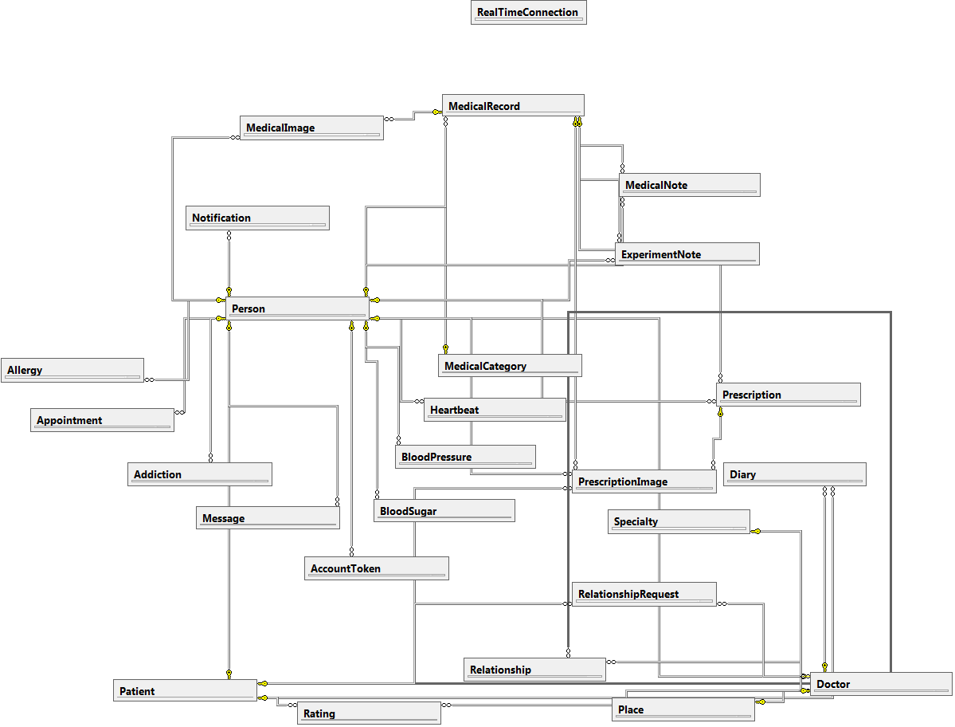

### 4.2. Table design

#### 4.2.1. Person

|  |  |  |  |  |  |
| --- | --- | --- | --- | --- | --- |
| Stores general information about users : Admin, Patients, Doctors. | | | | | |
| **No.** | **Field** | **Type** | **Key** | **Description** | **Null** |
| 1 | Id | INT | PK | The id of user | No |
| 2 | Email | VARCHAR(64) |  | Email which is used for account registration. This can be understood as account name | No |
| 3 | Password | VARCHAR(16) |  | Password of user | No |
| 4 | FirstName | NVARCHAR(32) |  | User first name | No |
| 5 | LastName | NVARCHAR(32) |  | User last name | No |
| 6 | FullName | NVARCHAR(96) |  | Full name of user, this is the combination of First Name and Last Name. It is created for quick access. | No |
| 7 | Birthday | FLOAT |  | Time when user was born. Its format is UTC. | No |
| 8 | Phone | VARCHAR(15) |  | User phone number | Yes |
| 9 | Gender | TINYINT |  | User gender | No |
| 10 | Role | TINYINT |  | Role in the system: Admin, patient or doctor | No |
| 11 | Created | FLOAT |  | Time when account was signed up | No |
| 12 | LastModified | FLOAT |  | Time when the account information was lastly modified | Yes |
| 13 | Status | TINYINT |  | Status of account : pending, disabled or active | No |
| 14 | Address | NVARCHAR(128) |  | Address where user lives or works | Yes |
| 15 | PhotoUrl | NVARCHAR(MAX) |  | Relative path of user photo, this is used for render hyperlink. | Yes |
| 16 | PhotoPhysicPath | NVARCHAR(MAX) |  | The physical path where photo is stored, this is used for file access. | Yes |

#### 4.2.2. Patient

|  |  |  |  |  |  |
| --- | --- | --- | --- | --- | --- |
| Stores general information about patients | | | | | |
| **No.** | **Field** | **Type** | **Key** | **Description** | **Null** |
| 1 | Id | INT | PK/FK | The id of patient. This is the same as person’s id | No |
| 2 | Height | FLOAT |  | Height of user | Yes |
| 3 | Weight | FLOAT |  | User weight | Yes |

#### 4.2.3. Doctor

|  |  |  |  |  |  |
| --- | --- | --- | --- | --- | --- |
| Stores general information about doctors | | | | | |
| **No.** | **Field** | **Type** | **Key** | **Description** | **Null** |
| 1 | Id | INT | PK/FK | The id of doctor. This is the same as person’s id | No |
| 2 | Rank | FLOAT |  | Doctor rank, this indicates how good the doctor is | Yes |
| 3 | SpecialtyId | INT | FK | Id of doctor specialty | No |
| 4 | Voters | INT |  | Number of people who voted for this doctor | Yes |
| 5 | PlaceId | INT | FK | Id of place where doctor lives or works | No |
| 6 | ProfileUrl | NVARCHAR(MAX) |  | Url of doctor profile file. | Yes |
| 7 | ProfilePhysicalPath | NVARCHAR(MAX) |  | Storage location on the server where real file is stored. | Yes |

#### 4.2.4. Place

|  |  |  |  |  |  |
| --- | --- | --- | --- | --- | --- |
| Stores general information about doctors | | | | | |
| **No.** | **Field** | **Type** | **Key** | **Description** | **Null** |
| 1 | Id | INT | PK/FK | The id of doctor. This is the same as person’s id | No |
| 2 | City | FLOAT |  | City name. | No |
| 3 | Country | INT | FK | Country name | No |

#### 4.2.5. Specialty

|  |  |  |  |  |  |
| --- | --- | --- | --- | --- | --- |
| Stores general information about medical specialty. | | | | | |
| **No.** | **Field** | **Type** | **Key** | **Description** | **Null** |
| 1 | Id | INT | PK | Id which is used for identifying specialties. | No |
| 2 | Name | NVARCHAR(32) |  | Specialty name | No |

#### 4.2.6. Diary

|  |  |  |  |  |  |
| --- | --- | --- | --- | --- | --- |
| Stores general information about medical diary. Diary is a personal of doctor about his/her one specific patient. | | | | | |
| **No.** | **Field** | **Type** | **Key** | **Description** | **Null** |
| 1 | Id | INT | PK | Diary unique index. | No |
| 2 | Owner | INT | FK | Id of doctor who owns the diary. | No |
| 3 | Target | INT | FK | Id of patient who diary notes about. | No |
| 4 | Time | FLOAT |  | Time when the diary was noted. | No |
| 5 | Note | NVARCHAR(512) |  | Diary note. | No |
| 6 | Created | FLOAT |  | Time when the diary was created. | No |
| 7 | LastModified | FLOAT |  | Time when the diary was lastly modified. | No |

#### 4.2.7. Rating

|  |  |  |  |  |  |
| --- | --- | --- | --- | --- | --- |
| Stores general information about rating: who made the rating, who was rated, … | | | | | |
| **No.** | **Field** | **Type** | **Key** | **Description** | **Null** |
| 1 | Maker | INT | PK/FK | Id of patient who made the rating, with Target, they combine to one primary key. | No |
| 2 | Target | INT | PK/FK | Id of doctor who was rated, with Maker, they combine to one primary key. | No |
| 3 | Value | INT |  | Rating point. | No |
| 4 | Comment | FLOAT |  | Comment of patient when rating was made. | No |
| 5 | Created | FLOAT |  | When the rating was created. | No |

#### 4.2.8. Relationship

|  |  |  |  |  |  |
| --- | --- | --- | --- | --- | --- |
| Stores general information about relationships between patients and doctors. | | | | | |
| **No.** | **Field** | **Type** | **Key** | **Description** | **Null** |
| 1 | Id | INT | PK | Id of relationship. | No |
| 2 | Source | INT | FK | Id of patient who started the relationship. | No |
| 3 | Target | INT | FK | Id of doctor who accepted the relationship. | No |
| 4 | Created | FLOAT |  | When the relationship was created. | No |

#### 4.2.9. RelationshipRequest

|  |  |  |  |  |  |
| --- | --- | --- | --- | --- | --- |
| Stores relationship requests information between patients and doctors. | | | | | |
| **No.** | **Field** | **Type** | **Key** | **Description** | **Null** |
| 1 | Id | INT | PK | Id of relationship. | No |
| 2 | Source | INT | FK | Id of patient who started the relationship request. | No |
| 3 | Target | INT | FK | Id of doctor who accepted the relationship request. | No |
| 4 | Content | NVARCHAR(128) |  | Message sent from patient to doctor about this request. | No |
| 5 | Created | FLOAT |  | When the relationship was sent. | Yes |

#### 4.2.10. Allergy

|  |  |  |  |  |  |
| --- | --- | --- | --- | --- | --- |
| Stores information of allergies which belong to patients. | | | | | |
| **No.** | **Field** | **Type** | **Key** | **Description** | **Null** |
| 1 | Id | INT | PK | Id of allergy note. | No |
| 2 | Owner | INT | FK | Id of patient who owns the allergy note. | No |
| 3 | Name | INT | FK | Name of allergy. | No |
| 4 | Cause | NVARCHAR(128) |  | Which patient is allergic with. | No |
| 5 | Note | FLOAT |  | Note information of allergy. | Yes |
| 6 | Created | FLOAT |  | When the note was created. | No |
| 7 | LastModified | FLOAT |  | When the note was lastly modified. | Yes |

#### 4.2.11. Addiction

|  |  |  |  |  |  |
| --- | --- | --- | --- | --- | --- |
| Stores information of addictions which belong to patients. | | | | | |
| **No.** | **Field** | **Type** | **Key** | **Description** | **Null** |
| 1 | Id | INT | PK | Id of addiction note. | No |
| 2 | Owner | INT | FK | Id of patient who owns the addiction note. | No |
| 3 | Cause | NVARCHAR(128) |  | Which patient is addictive with. | No |
| 4 | Note | FLOAT |  | Note information of addiction. | Yes |
| 5 | Created | FLOAT |  | When the note was created. | No |
| 6 | LastModified | FLOAT |  | When the note was lastly modified. | Yes |

#### 4.2.12. BloodPressure

|  |  |  |  |  |  |
| --- | --- | --- | --- | --- | --- |
| Stores information of blood pressure measurements which belong to patients. | | | | | |
| **No.** | **Field** | **Type** | **Key** | **Description** | **Null** |
| 1 | Id | INT | PK | Id of blood pressure note. | No |
| 2 | Owner | INT | FK | Id of patient who owns the note. | No |
| 3 | Systolic | INT |  | Max pressure of blood. | No |
| 4 | Diastolic | INT |  | Min pressure of blood. | No |
| 5 | Time | FLOAT |  | When the measurement was done. | No |
| 6 | Note | FLOAT |  | Note information of addiction. | Yes |
| 7 | Created | FLOAT |  | When the note was created. | No |
| 8 | LastModified | FLOAT |  | When the note was lastly modified. | Yes |

#### 4.2.13. Heartbeat

|  |  |  |  |  |  |
| --- | --- | --- | --- | --- | --- |
| Stores information of heartbeat measurements which belong to patients. | | | | | |
| **No.** | **Field** | **Type** | **Key** | **Description** | **Null** |
| 1 | Id | INT | PK | Id of blood pressure note. | No |
| 2 | Owner | INT | FK | Id of patient who owns the note. | No |
| 3 | Rate | FLOAT |  | Heart rate at the time measurement was done. | No |
| 4 | Time | FLOAT |  | When the measurement was done. | No |
| 5 | Note | FLOAT |  | Note information of addiction. | Yes |
| 6 | Created | FLOAT |  | When the note was created. | No |
| 7 | LastModified | FLOAT |  | When the note was lastly modified. | Yes |

#### 4.2.14. BloodSugar

|  |  |  |  |  |  |
| --- | --- | --- | --- | --- | --- |
| Stores information of blood sugar measurements which belong to patients. | | | | | |
| **No.** | **Field** | **Type** | **Key** | **Description** | **Null** |
| 1 | Id | INT | PK | Id of blood sugar note. | No |
| 2 | Owner | INT | FK | Id of patient who owns the note. | No |
| 3 | Value | FLOAT |  | Blood sugar level at the time measurement was done. | No |
| 4 | Time | FLOAT |  | When the measurement was done. | No |
| 5 | Note | FLOAT |  | Note information of addiction. | Yes |
| 6 | Created | FLOAT |  | When the note was created. | No |
| 7 | LastModified | FLOAT |  | When the note was lastly modified. | Yes |

#### 4.2.15. MedicalRecord

|  |  |  |  |  |  |
| --- | --- | --- | --- | --- | --- |
| Stores information of medical records which belong to patients. | | | | | |
| **No.** | **Field** | **Type** | **Key** | **Description** | **Null** |
| 1 | Id | INT | PK | Id of medical record. | No |
| 2 | Owner | INT | FK | Who owned the record. | No |
| 3 | Creator | INT | FK | Who created medical record. | No |
| 4 | Category | INT |  | Category which medical record belongs to. | No |
| 5 | Name | NVARCHAR(64) |  | Name of medical record. | Yes |
| 6 | Info | NVARCHAR(MAX) |  | Key-value of necessary information.I.e : “Eye”:”good” | Yes |
| 7 | Time | FLOAT |  | When the record was about. | Yes |
| 8 | Created | FLOAT |  | When the record was created. | No |
| 9 | LastModified | FLOAT |  | When the note was lastly modified. | Yes |

#### 4.2.16. Prescription

|  |  |  |  |  |  |
| --- | --- | --- | --- | --- | --- |
| Stores information of prescriptions which belong to patients. | | | | | |
| **No.** | **Field** | **Type** | **Key** | **Description** | **Null** |
| 1 | Id | INT | PK | Id of prescription. | No |
| 2 | Owner | INT | FK | Who owns the prescription. | No |
| 3 | Creator | INT | FK | Who created prescription. | No |
| 4 | MedicalRecordId | INT | FK | Id of medical record which prescription belongs to. | No |
| 5 | From | FLOAT |  | When the prescription should be available. | No |
| 6 | To | FLOAT |  | When the prescription should be expired | No |
| 7 | Name | NVARCHAR(32) |  | Name of prescription | No |
| 8 | Medicine | NVARCHAR(MAX) |  | Stores serialized information of medicine. Refer to API documentation for more detail (api/medical/prescription) | Yes |
| 9 | Note | NVARCHAR(128) |  | Note of prescription. | Yes |
| 10 | Created | FLOAT |  | When the prescription was created. | No |
| 11 | LastModified | FLOAT |  | When the prescription was lastly modified. | Yes |

#### 4.2.17. PrescriptionImage

|  |  |  |  |  |  |
| --- | --- | --- | --- | --- | --- |
| Stores information of prescription images which belong to patients. | | | | | |
| **No.** | **Field** | **Type** | **Key** | **Description** | **Null** |
| 1 | Id | INT | PK | Id of prescription image. | No |
| 2 | Owner | INT | FK | Who owns the prescription image. | No |
| 3 | Creator | INT | FK | Who created prescription image. | No |
| 4 | MedicalRecordId | INT | FK | Id of medical record which prescription image belongs to. | No |
| 5 | PrescriptionId | INT | FK | Id of prescription which prescription image belongs to. | No |
| 6 | Image | NVARCHAR(32) |  | Name of image. | No |
| 7 | FullPath | NVARCHAR(MAX) |  | Physical path where image is stored on server. | No |
| 8 | Created | FLOAT |  | When the prescription image was created. | No |
| 9 | LastModified | FLOAT |  | When the prescription image was lastly modified. | Yes |

#### 4.2.18. MedicalNote

|  |  |  |  |  |  |
| --- | --- | --- | --- | --- | --- |
| Stores information of medical notes which belong to patients. | | | | | |
| **No.** | **Field** | **Type** | **Key** | **Description** | **Null** |
| 1 | Id | INT | PK | Id of prescription image. | No |
| 2 | Owner | INT | FK | Who owns the prescription image. | No |
| 3 | Creator | INT | FK | Who created prescription image. | No |
| 4 | MedicalRecordId | INT | FK | Id of medical record which note belongs to. | No |
| 5 | Note | NVARCHAR(128) |  | Note of medical record. | No |
| 6 | Time | INT |  | Time when the note was about. | No |
| 7 | Created | FLOAT |  | When the note was created. | No |
| 8 | LastModified | FLOAT |  | When the note was lastly modified. | Yes |

#### 4.2.19. MedicalCategory

|  |  |  |  |  |  |
| --- | --- | --- | --- | --- | --- |
| Stores information of medical category which medical records belong to. | | | | | |
| **No.** | **Field** | **Type** | **Key** | **Description** | **Null** |
| 1 | Id | INT | PK | Id of prescription image. | No |
| 2 | Name | NVARCHAR(32) |  | Name of medical category. | No |
| 3 | Created | FLOAT |  | When the category was created. | No |
| 4 | LastModified | FLOAT |  | When the category was lastly modified. | Yes |

#### 4.2.20. MedicalImage

|  |  |  |  |  |  |
| --- | --- | --- | --- | --- | --- |
| Stores information of medical image which are contained in medical records. | | | | | |
| **No.** | **Field** | **Type** | **Key** | **Description** | **Null** |
| 1 | Id | INT | PK | Id of .medical image. | No |
| 2 | MedicalRecordId | INT | FK | Id of medical record which medical image belongs to. | No |
| 3 | Owner | INT | FK | Id of person who owns the medical image. | No |
| 4 | Creator | INT | FK | Id of person who created medical image. | No |
| 5 | Image | NVARCHAR(32) |  | Name of image. | No |
| 6 | FullPath | NVARCHAR(MAX) |  | Physical path on server where image is stored. | No |
| 7 | Created | FLOAT |  | When medical image was created. | No |

#### 4.2.21. MedicalRecord

|  |  |  |  |  |  |
| --- | --- | --- | --- | --- | --- |
| Stores information of medical image which are contained in medical records. | | | | | |
| **No.** | **Field** | **Type** | **Key** | **Description** | **Null** |
| 1 | Id | INT | PK | Id of of experiment note. | No |
| 2 | MedicalRecordId | INT | FK | Id of medical record which medical record belongs to. | No |
| 3 | Owner | INT | FK | Id of person who owns the experiment note. | No |
| 4 | Creator | INT | FK | Id of person who created experiment note. | No |
| 5 | Name | INT |  | Name of experiment note. | No |
| 6 | Info | INT |  | Stores serialized information of experiment measurement. | No |
| 7 | Time | INT |  | Time when the experiment note is about. | No |
| 8 | Created | FLOAT |  | When medical image was created. | No |
| 9 | LastModified | FLOAT |  | When medical image was lastly modified. | No |

#### 4.2.22. Notification

|  |  |  |  |  |  |
| --- | --- | --- | --- | --- | --- |
| Stores information of notification which broadcasted from service. | | | | | |
| **No.** | **Field** | **Type** | **Key** | **Description** | **Null** |
| 1 | Id | INT | PK | Id of of notification. | No |
| 2 | Type | INT |  | Type of notification : create/edit/remove/… | No |
| 3 | Topic | INT |  | Topic of notification : Medical record/ Prescription/… | No |
| 4 | Container | INT |  | Id of the container (Medical Record ID, Prescription ID, …). | No |
| 5 | ContainerType | INT |  | Type of container (Medical Record, Prescription, …). | No |
| 6 | Broadcaster | INT |  | Who causes the notification broadcasted. | No |
| 7 | Recipient | INT |  | Who should receive the notification. | No |
| 8 | Record | FLOAT |  | Id of record which is targeted. | No |
| 9 | Message | FLOAT |  | Message from service. | No |
| 10 | Created | FLOAT |  | When the notification is created. | No |
| 11 | IsSeen | FLOAT |  | Whether recipient has seen the notification or not. | No |

#### 4.2.23. RealtimeConnection

|  |  |  |  |  |  |
| --- | --- | --- | --- | --- | --- |
| Stores information of connections made to service, the connections information will be used by service to broadcast realtime notification to clients. | | | | | |
| **No.** | **Field** | **Type** | **Key** | **Description** | **Null** |
| 1 | Id | INT | PK | Id of of realtime connection. | No |
| 2 | Owner | INT |  | Id of person who connects to service. | No |
| 3 | ConnectionId | INT |  | Connection index which generated by service. | No |
| 4 | Created | INT |  | Time when the note was created. | No |

#### 4.2.24. Message

|  |  |  |  |  |  |
| --- | --- | --- | --- | --- | --- |
| Stores information of message which are broadcasted on server. | | | | | |
| **No.** | **Field** | **Type** | **Key** | **Description** | **Null** |
| 1 | Id | INT | PK | Id of of message. | No |
| 2 | Broadcaster | INT | FK | Id of person who broadcasted the message. | No |
| 3 | Recipient | INT | FK | Id of person who receives the message. | No |
| 4 | Content | NVARCHAR(512) |  | Message content. | No |
| 5 | Created | FLOAT |  | Time when the message was broadcasted. | No |
| 6 | IsSeen | BIT |  | Whether message has been seen or not. | No |

#### 4.2.25. AccountToken

|  |  |  |  |  |  |
| --- | --- | --- | --- | --- | --- |
| Stores information of tokens which are used for account activation or account password modification. | | | | | |
| **No.** | **Field** | **Type** | **Key** | **Description** | **Null** |
| 1 | Owner | INT | PK/FK | Id of patient who has the code. | No |
| 2 | Code | NVARCHAR(36) |  | Code for account activation/account password modification. | No |
| 3 | Type | INT | PK/FK | Id of person who receives the message. | No |
| 4 | Expired | DATETIME |  | Time when the account token is expired. | No |

#### 4.2.26. Appointment

|  |  |  |  |  |  |
| --- | --- | --- | --- | --- | --- |
| Appointment information which is broadcasted from patients to doctors and vice versa. | | | | | |
| **No.** | **Field** | **Type** | **Key** | **Description** | **Null** |
| 1 | Id | INT | PK/FK | Appointment index. | No |
| 2 | Maker | INT | FK | Id of person who made the appointment request. | No |
| 3 | Dater | INT | FK | Id of person who received the appointment request. | No |
| 4 | From | FLOAT |  | Time when the appointment should be started. | No |
| 5 | To | FLOAT |  | Time when the appointment should be emded. | No |
| 6 | Note | NVARCHAR(128) |  | Note of appointment | No |
| 7 | Created | FLOAT |  | Time when the appointment was created. | No |
| 8 | LastModified | FLOAT |  | Time when the appointment was lastly modified. | No |
| 9 | LastModifiedNote | NVARCHAR(128) |  | Note of the time appointment was lastly modified. | Yes |
| 10 | Status | TINYINT |  | Status of appointment | No |

## References

## Detail design

### 6.1. General sequence diagram

Olives back-end services and front-end applications all have some general sequence diagram which will be used by Components Assemblers in development stage. As in a specific function, sequence diagram is not defined, that function should follows the general sequence diagram.

#### 6.1.1 Olives back-end general sequence diagrams

##### 6.1.1.1. Find record

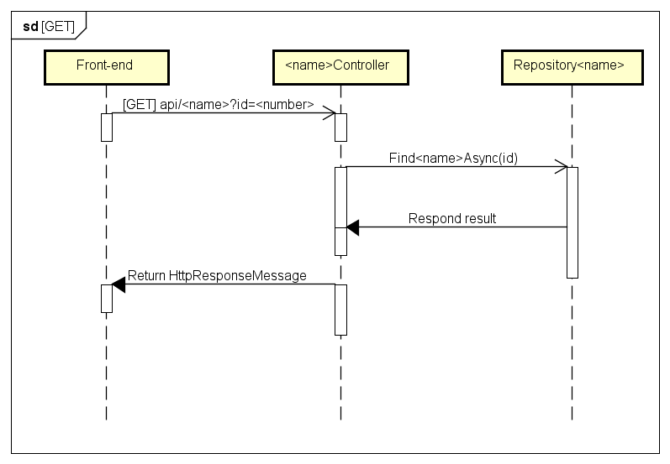

##### 6.1.1.2. Initialize record

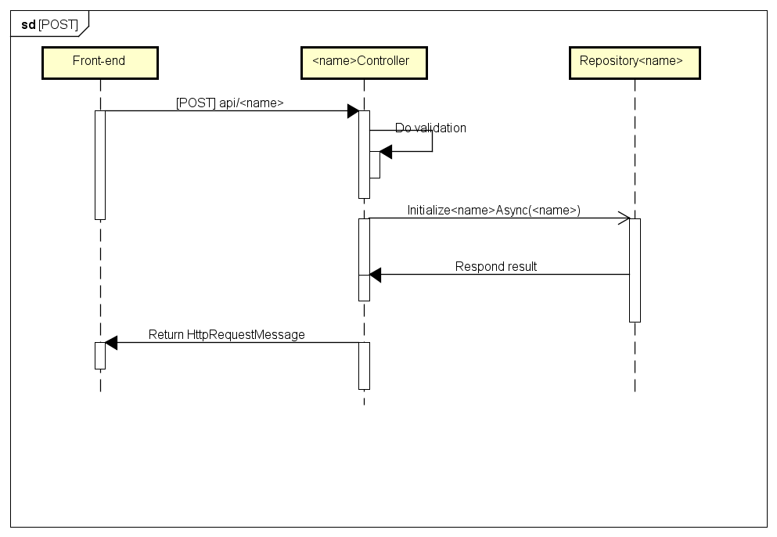

##### 6.1.1.3. Edit record

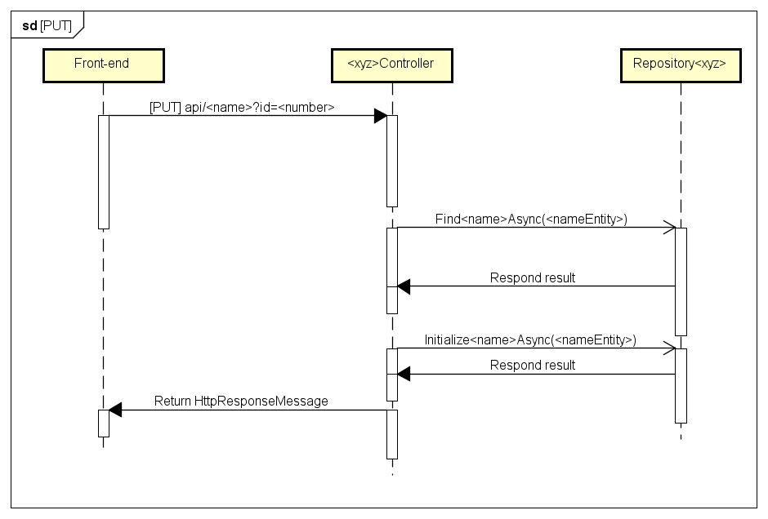

##### 6.1.1.4. Delete record

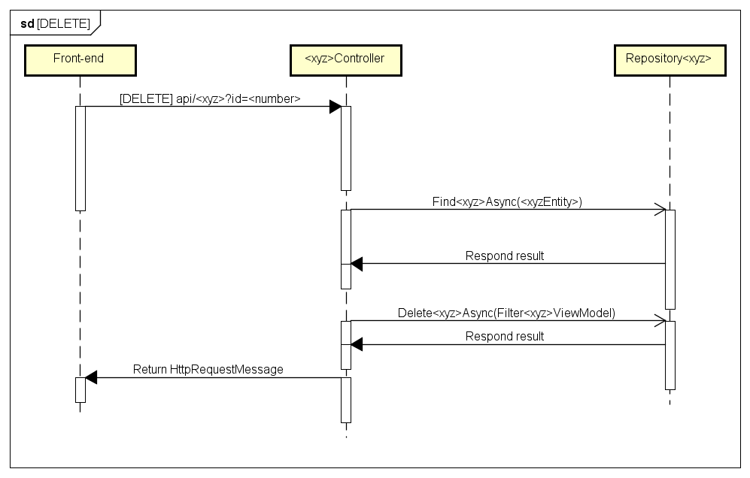

##### 6.1.1.5. Filter record

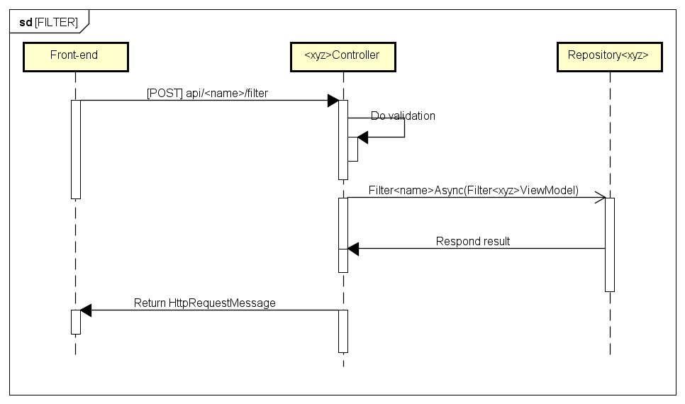

#### 6.1.2. Olives front-end general sequence diagrams (Patient application)

##### 6.1.2.1. Non-medical records data sequence

This type of sequence is for data which doesn’t belong to these types: Medical Record, Experiment Note, Medical Note, Medical Category, Medical Image, Prescription, Prescription Image.

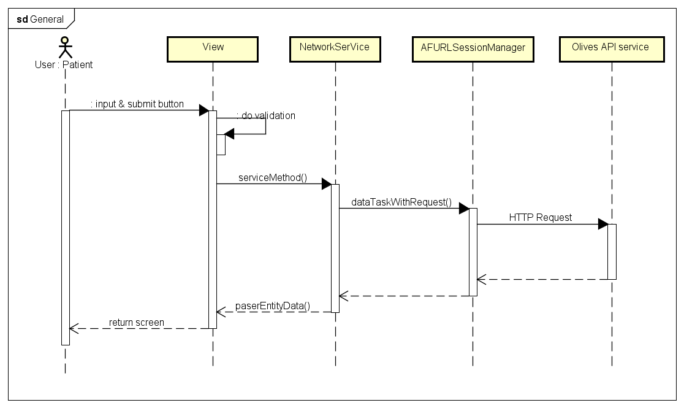

##### 6.1.2.2. Medical records data sequence

This type of sequence is for data which belongs to those excluded data types above.

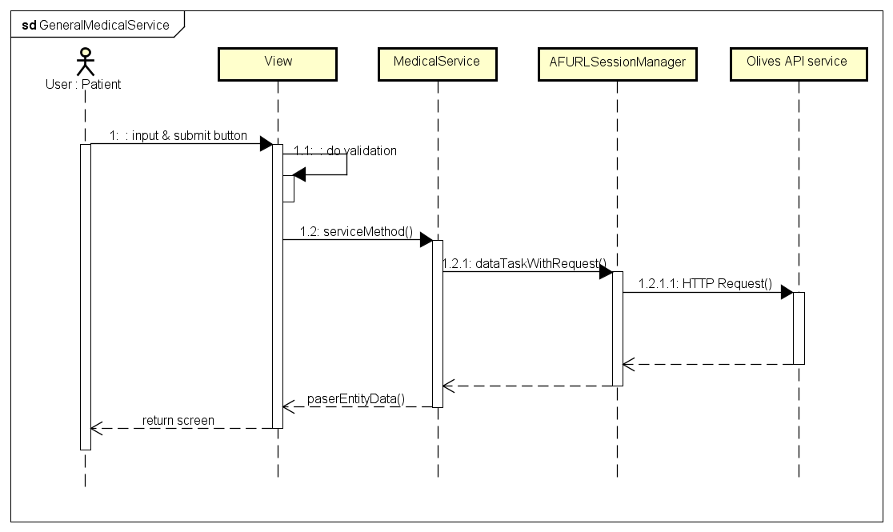

#### 6.1.3. Example of ordinary sequence diagrams

##### 6.1.3.1. Initialize blood pressure note

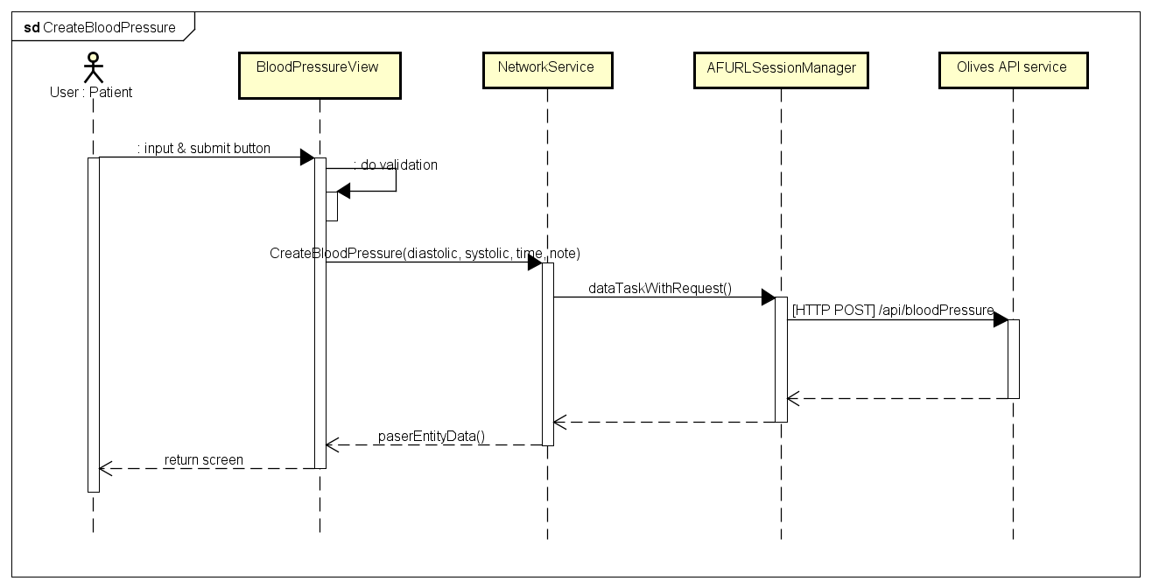

##### 6.1.3.3. Initialize appointment

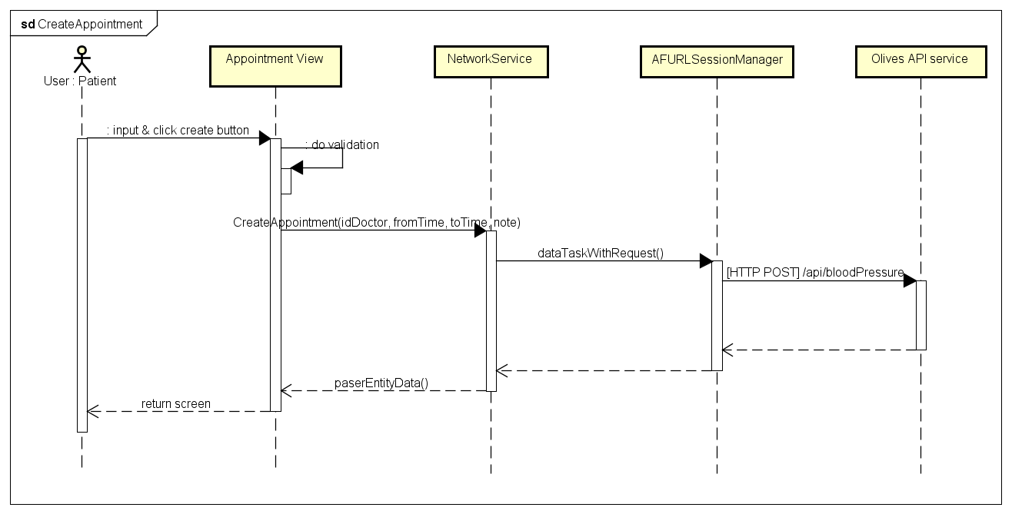

### 6.2. Detail design & use case

#### 6.2.1. Olives Administration sub-system

##### 6.2.1.1. Login

###### a. Class diagram

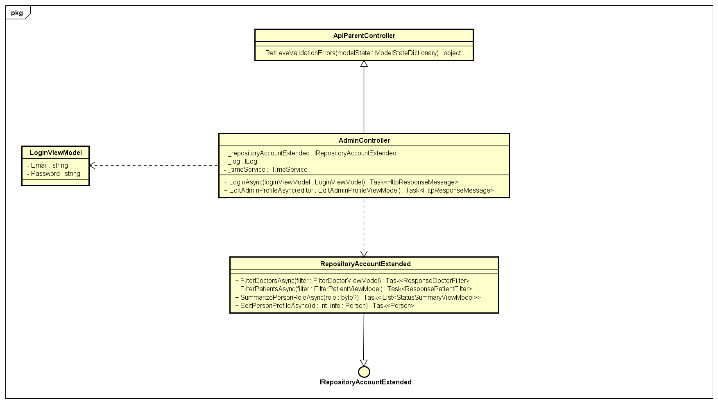

Class diagram of Admin Login.

###### b. Sequence diagram

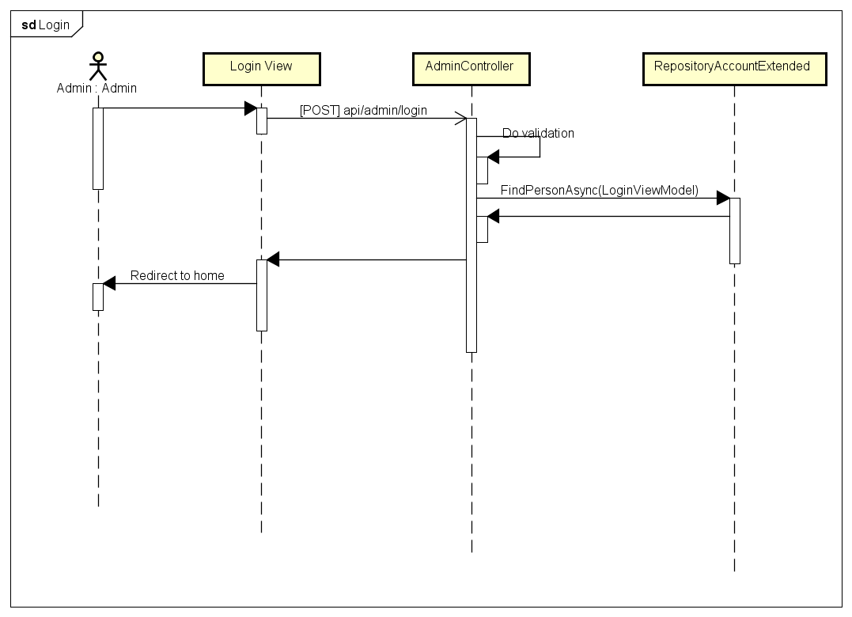

###### c. Class definition

ApiParentController class

*[Method]RetrieveValidationErrors()*

|  |  |  |  |  |
| --- | --- | --- | --- | --- |
| Purpose | Take the request parameter model and do the validation and construct a list of validation errors as available which should be seen by clients. | | | |
| Return | **Type** | | | **Description** |
| object | | | Validation error response. |
| Parameter | **No** | **Name** | **Type** | **Description** |
| 1 | modelState | ModelStateDictionary | ModelState of MVC/Web API which contains request parameters. |

AdminController class

*Attributes*

|  |  |  |  |
| --- | --- | --- | --- |
| No | Name | Type | Description |
| 1 | _repositoryAccountExtended | var | Instance of interface using to call methods in IRepositoryAccountExtended. |
| 2 | _log | var | Instance of interface using to call methods in ILog. |
| 3 | _timeService | var | Instance of interface using to call methods in ITimeService. |

*[Method]LoginAsync()*

|  |  |  |  |  |
| --- | --- | --- | --- | --- |
| Purpose | Take the parameters come from clients, do validation and log user into system as the information is valid. | | | |
| Return | **Type** | | | **Description** |
| HttpResponseMessage | | | Response message which is thrown back to front-end to handle the processed result. |
| Parameter | **No** | **Name** | **Type** | **Description** |
| 1 | loginViewModel | LoginViewModel | A view model contains Email and Password which are used for logging into system. |

*[Method]EditAdminProfileAsync()*

|  |  |  |  |  |
| --- | --- | --- | --- | --- |
| Purpose | Take the parameters come from clients, do validation and edit the profile of admin as the information is valid. | | | |
| Return | **Type** | | | **Description** |
| HttpResponseMessage | | | Response message which is thrown back to front-end to handle the processed result. |
| Parameter | **No** | **Name** | **Type** | **Description** |
| 1 | editor | EditAdminProfileViewModel | A view model contains the information which is used for changing information in profile. |

RepositoryAccountExtended class

*Attributes*

|  |  |  |  |
| --- | --- | --- | --- |
| No | Name | Type | Description |
| 1 | _dataContext | var | Instance of interface using to call methods in IOliveDataContext. |

*[Method]FilterDoctorAsync()*

|  |  |  |  |  |
| --- | --- | --- | --- | --- |
| Purpose | Take the request parameters, filter and return a list of condition matched doctors. | | | |
| Return | **Type** | | | **Description** |
| ResponseDoctorFilter | | | Contains a filtered results list and a total record counter. |
| Parameter | **No** | **Name** | **Type** | **Description** |
| 1 | filter | FilterDoctorViewModel | Model contains the conditions which are used for filtering. |

*[Method]FilterPatientsAsync()*

|  |  |  |  |  |
| --- | --- | --- | --- | --- |
| Purpose | Take the request parameters, filter and return a list of condition matched patients. | | | |
| Return | **Type** | | | **Description** |
| ResponsePatientFilter | | | Contains a filtered results list and a total record counter. |
| Parameter | **No** | **Name** | **Type** | **Description** |
| 1 | filter | FilterPatientViewModel | Model contains the conditions which are used for filtering. |

*[Method]SummarizePersonRoleAsync()*

|  |  |  |  |  |
| --- | --- | --- | --- | --- |
| Purpose | Take the request parameters, filter and return a list of condition matched people with role statistic. | | | |
| Return | **Type** | | | **Description** |
| IList<StatusSummaryViewModel> | | | Contains a filtered results list and a total record counter. |
| Parameter | **No** | **Name** | **Type** | **Description** |
| 1 | role | Byte? | Role which is used for determining the filter. |

##### 6.2.1.2. Logout

1. Sequence diagram

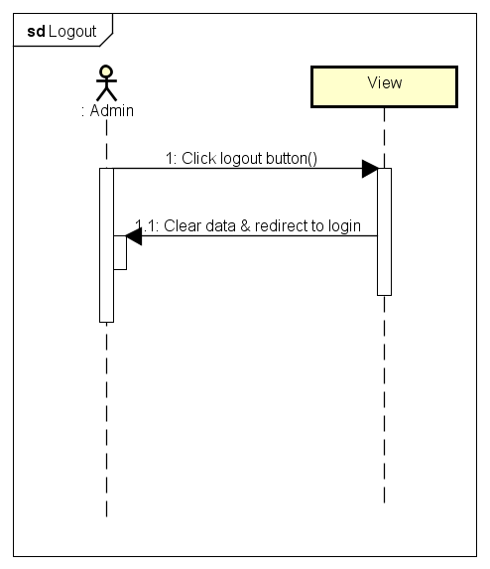

##### 6.2.1.3. Create medical category

1. Class diagram

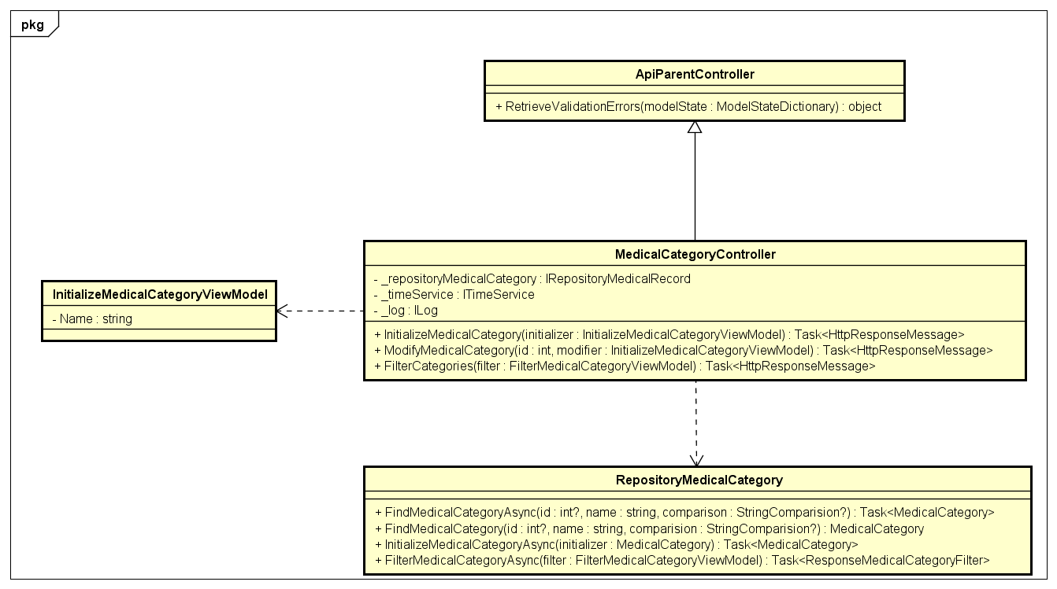

1. Class definition

MedicalCategoryController class

Attribute

|  |  |  |  |
| --- | --- | --- | --- |
| No | Name | Type | Description |
| 1 | _repositoryMedicalCategory | var | Instance of interface using to call methods in IRepositoryMedicalCategory. |
| 2 | _timeService | var | Instance of interface using to call methods in ITimeService. |
| 3 | _log | var | Instance of interface using to call methods in IRepositoryMedicalCategory. |

Method: InitializeMedicalCategory()

|  |  |  |  |  |
| --- | --- | --- | --- | --- |
| Purpose | Take the request parameters, validate and initialize a medical category as the information is valid. | | | |
| Return | **Type** | | | **Description** |
| HttpResponseMessage | | | Contains the information which will be thrown back to the clients. |
| Parameter | **No** | **Name** | **Type** | **Description** |
| 1 | initializer | InitializeMedicalCategoryViewModel | Model contains the information of medical record which will be used for initializing a medical category. |

Method: ModifyMedicalCategory()

|  |  |  |  |  |
| --- | --- | --- | --- | --- |
| Purpose | Take the request parameters, validate and modify a medical category as the information is valid | | | |
| Return | **Type** | | | **Description** |
| HttpResponseMessage | | | Contains the information which will be thrown back to the clients. |
| Parameter | **No** | **Name** | **Type** | **Description** |
| 1 | id | int | Id of medical category which will be targeted to be edited. |
| 2 | modifier | InitializeMedicalCategoryViewModel | Model contains the information of medical record which will be used for modifying a medical category. |

Method: FilterCategories()

|  |  |  |  |  |
| --- | --- | --- | --- | --- |
| Purpose | Take the request parameters, validate and filter and return the list of condition matched medical categories. | | | |
| Return | **Type** | | | **Description** |
| HttpResponseMessage | | | Contains the information which will be thrown back to the clients. |
| Parameter | **No** | **Name** | **Type** | **Description** |
| 2 | filter | FilterMedicalCategoryViewModel | Model contains the information which are used for medical categories filtering. |

##### 6.2.1.4. Edit medical category

1. Class diagram



##### 6.2.1.5. Filter medical category

###### a. Class diagram

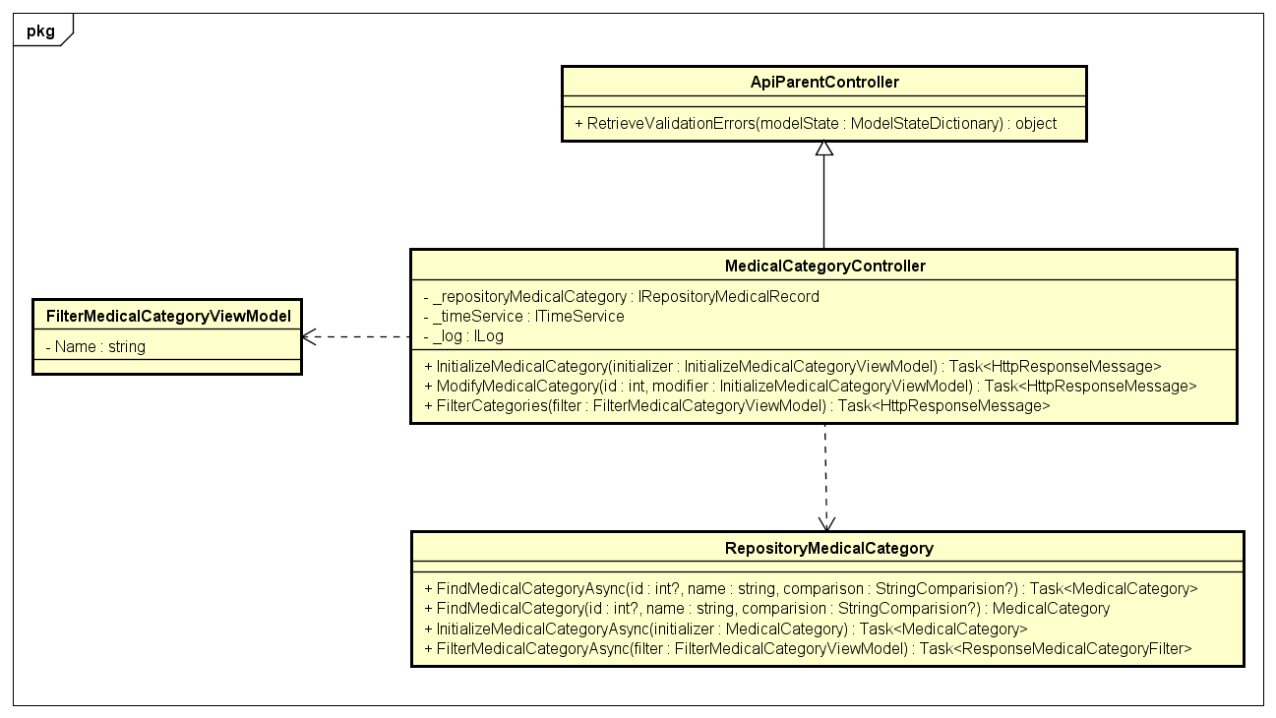

##### 6.2.1.6. Activate account

1. Class diagram

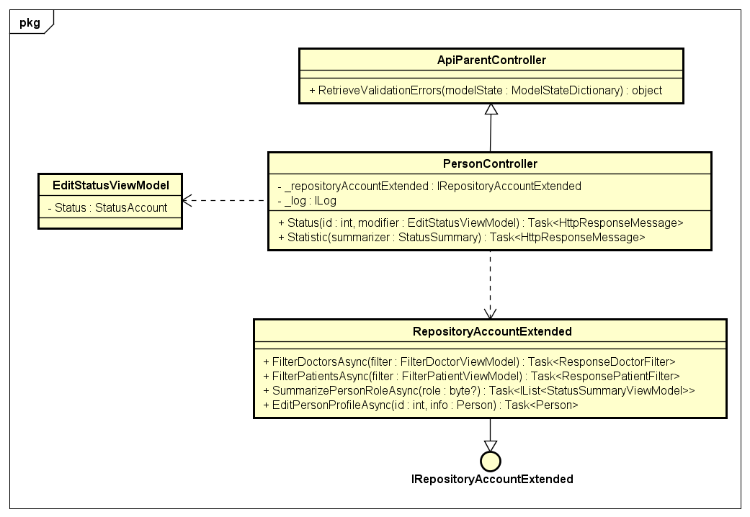

1. Sequence diagram

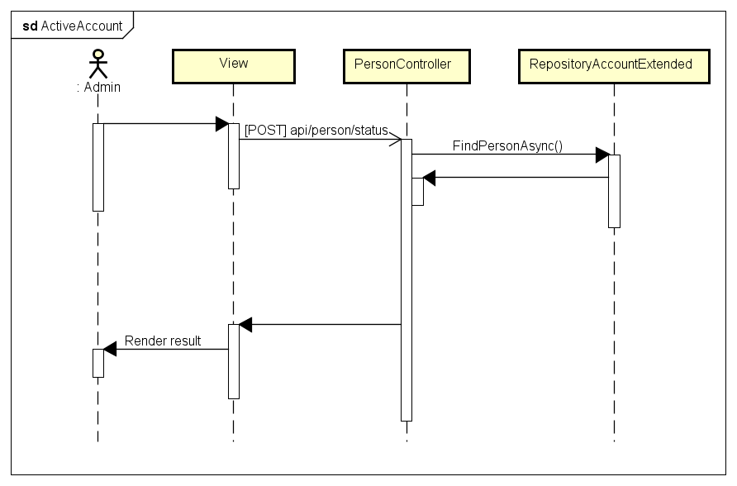

##### 6.2.1.7. Find doctor

1. Class diagram

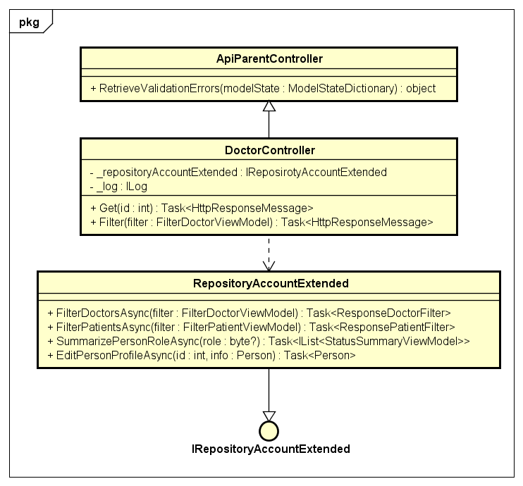

1. Class definition

DoctorController class

Attribute

|  |  |  |  |
| --- | --- | --- | --- |
| No | Name | Type | Description |
| 1 | _repositoryMedicalCategory | var | Instance of interface using to call methods in IRepositoryMedicalCategory. |
| 2 | _timeService | var | Instance of interface using to call methods in ITimeService. |
| 3 | _log | var | Instance of interface using to call methods in IRepositoryMedicalCategory. |

Method: Get()

|  |  |  |  |  |
| --- | --- | --- | --- | --- |
| Purpose | Take the id sent from client and find the doctor by using id. | | | |
| Return | **Type** | | | **Description** |
| HttpResponseMessage | | | Contains the information which will be thrown back to the clients. |
| Parameter | **No** | **Name** | **Type** | **Description** |
| 1 | id | int | Id of doctor. |

Method: Filter()

|  |  |  |  |  |
| --- | --- | --- | --- | --- |
| Purpose | Take the id sent from client and find the doctor by using id. | | | |
| Return | **Type** | | | **Description** |
| HttpResponseMessage | | | Contains the information which will be thrown back to the clients. |
| Parameter | **No** | **Name** | **Type** | **Description** |
| 1 | filter | FilterDoctorViewModel | Model contains the information for filter. |

##### 6.2.1.8. Filter doctors

1. Class diagram

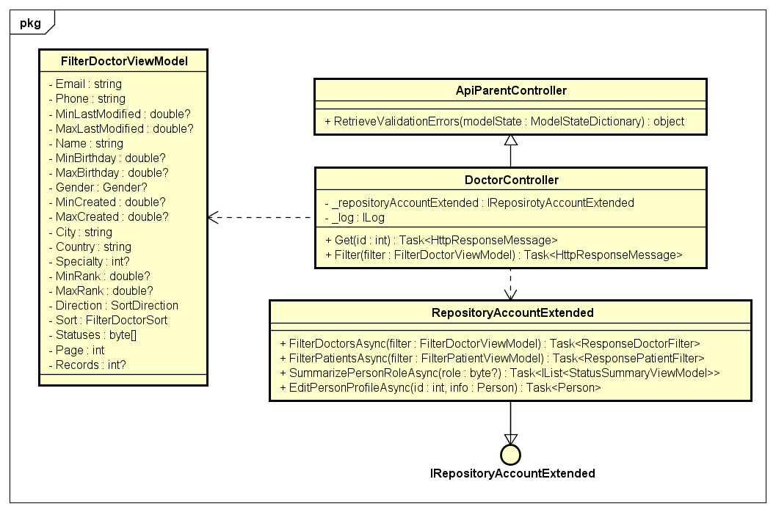

##### 6.2.1.9. Find patients

1. Class diagram

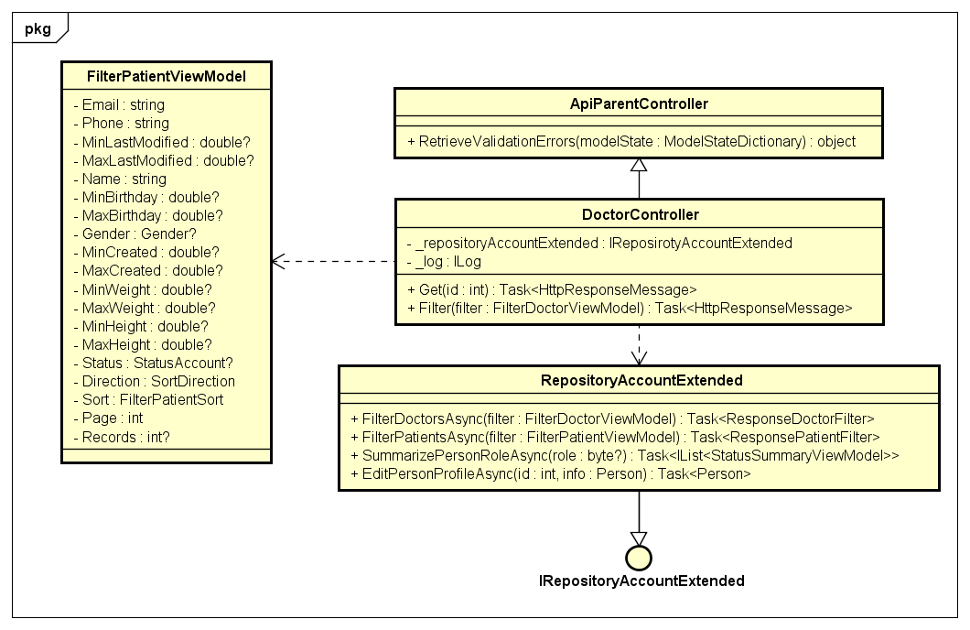

##### 6.2.1.10. Statistic accounts by role

1. Class diagram

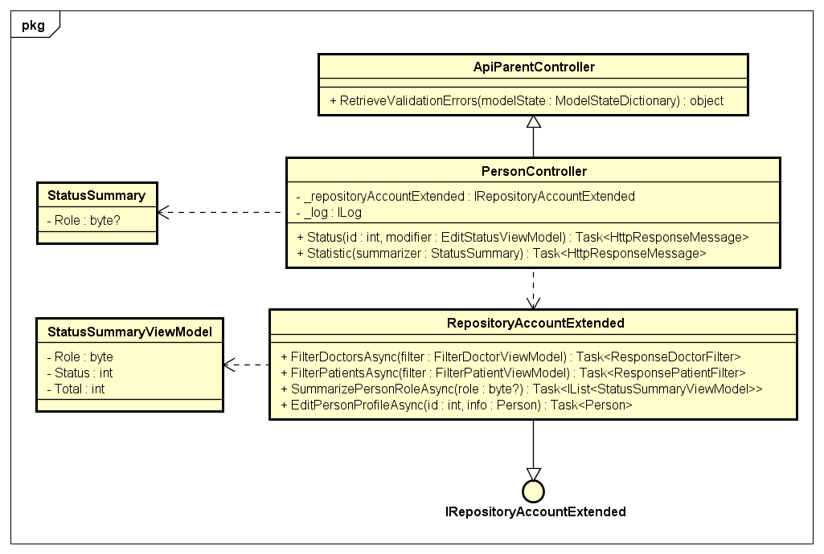

1. Sequence diagram

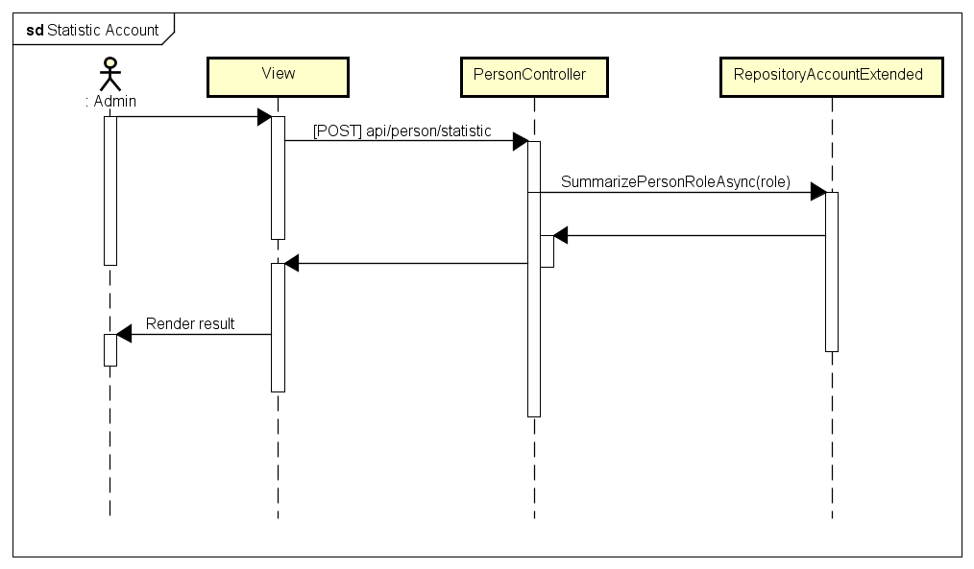

1. Class diagram

PersonController class

Attribute

|  |  |  |  |
| --- | --- | --- | --- |
| No | Name | Type | Description |
| 1 | _repositoryMedicalCategory | var | Instance of interface using to call methods in IRepositoryMedicalCategory. |
| 2 | _timeService | var | Instance of interface using to call methods in ITimeService. |
| 3 | _log | var | Instance of interface using to call methods in IRepositoryMedicalCategory. |

Method: Status()

|  |  |  |  |  |
| --- | --- | --- | --- | --- |
| Purpose | Take the id sent from client and find the person by using id. | | | |
| Return | **Type** | | | **Description** |
| HttpResponseMessage | | | Contains the information which will be thrown back to the clients. |
| Parameter | **No** | **Name** | **Type** | **Description** |
| 1 | id | int | Id of doctor. |
| 2 | modifier | EditStatusViewModel | Model contains information which is used for modifying person status. |

##### 6.2.1.11. Initialize place

1. Class diagram

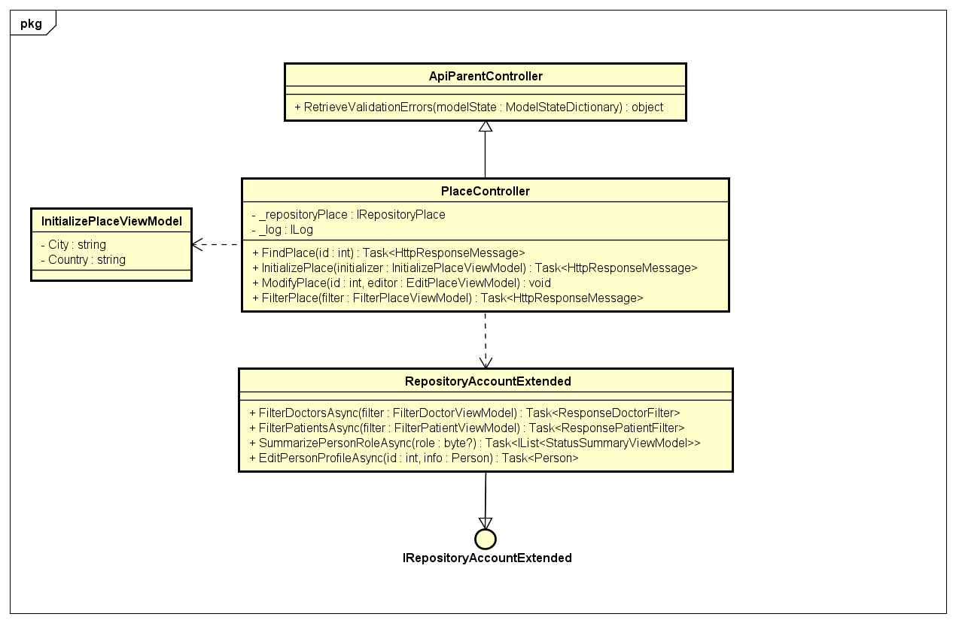

1. Class definition

PlaceController class

Attribute

|  |  |  |  |
| --- | --- | --- | --- |
| No | Name | Type | Description |
| 1 | _repositoryPlace | IRepositoryPlace | Instance of interface using to call methods in IRepositoryPlace. |
| 2 | _log | ILog | Instance of interface using to call methods in ILog. |

Method: FindPlace()

|  |  |  |  |  |
| --- | --- | --- | --- | --- |
| Purpose | Take the id sent from client and find the place by using id. | | | |
| Return | **Type** | | | **Description** |
| HttpResponseMessage | | | Contains the information which will be thrown back to the clients. |
| Parameter | **No** | **Name** | **Type** | **Description** |
| 1 | id | int | Id of place. |

Method: InitializePlace()

|  |  |  |  |  |
| --- | --- | --- | --- | --- |
| Purpose | Take the information requested from client and create a place in database as the informations is available. | | | |
| Return | **Type** | | | **Description** |
| HttpResponseMessage | | | Contains the information which will be thrown back to the clients. |
| Parameter | **No** | **Name** | **Type** | **Description** |
| 1 | initializer | InitializePlaceViewModel | Model which contains place information for being initialized. |

Method: ModifyPlace()

|  |  |  |  |  |
| --- | --- | --- | --- | --- |
| Purpose | Take the information requested from client, do validation and modify place information as the parameters are valid. | | | |
| Return | **Type** | | | **Description** |
| HttpResponseMessage | | | Contains the information which will be thrown back to the clients. |
| Parameter | **No** | **Name** | **Type** | **Description** |
| 1 | id | int | Id of place which needs modifying |
| 2 | initializer | EditPlaceViewModel | Collection of information which is used for replacing the old ones. |

Method: FilterPlace()

|  |  |  |  |  |
| --- | --- | --- | --- | --- |
| Purpose | Take the information requested from client, do validation filter places list as parameters are valid. | | | |
| Return | **Type** | | | **Description** |
| HttpResponseMessage | | | Contains the information which will be thrown back to the clients. |
| Parameter | **No** | **Name** | **Type** | **Description** |
| 2 | filter | FilterPlaceViewModel | Class which contains conditions to filter places. |

##### 6.2.1.12. Edit place

1. Class diagram

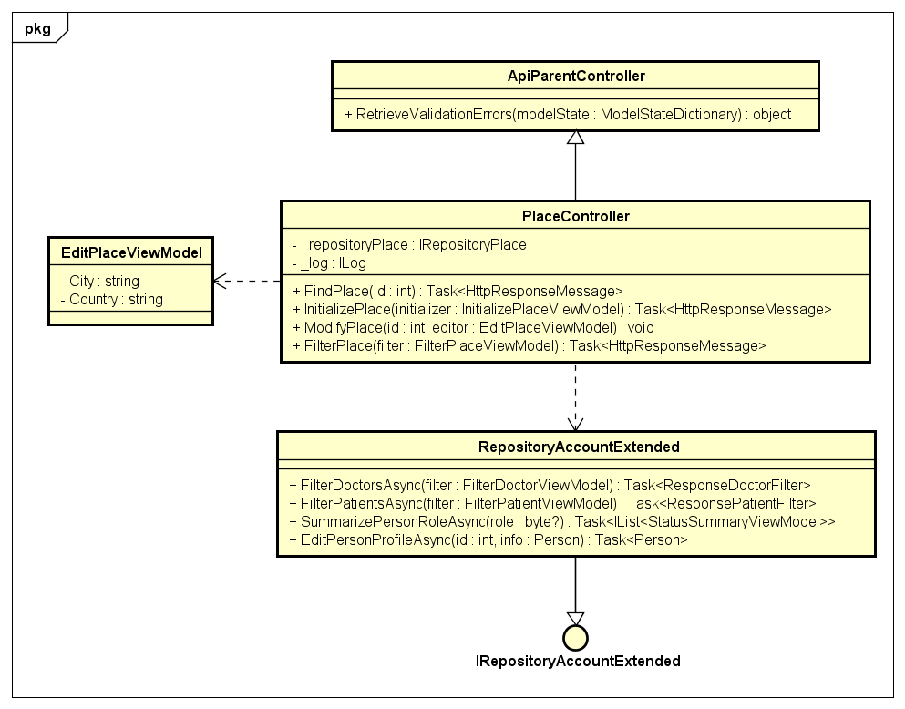

#### 6.2.2. Olives sub-system (Back-end)

##### 6.2.1.1. Login

1. Class diagram

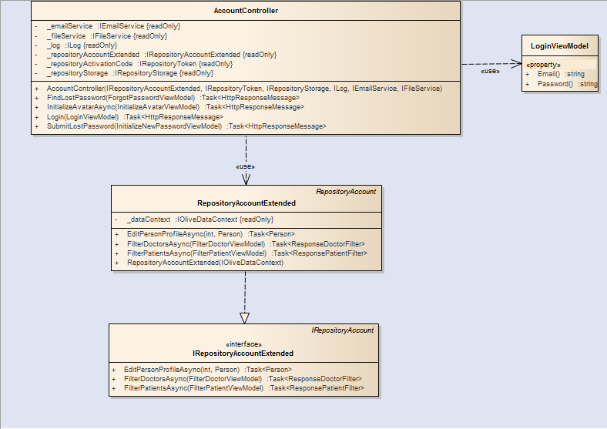

1. Class definition

PlaceController class

Attribute

|  |  |  |  |
| --- | --- | --- | --- |
| No | Name | Type | Description |
| 1 | _dataContext | IOliveDataContext | Instance of interface using to call methods in IOliveDataContext. |

Method: FilterDoctorsAsync()

|  |  |  |  |  |
| --- | --- | --- | --- | --- |
| Purpose | Find doctors by using specific conditions. | | | |
| Return | **Type** | | | **Description** |
| ResponseDoctorFilter | | | Contains a list of filtered doctors and number which represents total filtered results. |
| Parameter | **No** | **Name** | **Type** | **Description** |
| 1 | filter | FilterDoctorViewModel | Model contains conditions which are used for filtering conditions. |

Method: FilterPatientsAsync()

|  |  |  |  |  |
| --- | --- | --- | --- | --- |
| Purpose | Find patients by using specific conditions. | | | |
| Return | **Type** | | | **Description** |
| ResponsePatientFilter | | | Contains a list of filtered patients and number which represents total filtered results. |
| Parameter | **No** | **Name** | **Type** | **Description** |
| 1 | filter | FilterDoctorViewModel | Model contains conditions which are used for filtering conditions. |

Method: EditPersonProfileAsync()

|  |  |  |  |  |
| --- | --- | --- | --- | --- |
| Purpose | Edit person by using specific information. | | | |
| Return | **Type** | | | **Description** |
| Person | | | Instance which contains edited information. |
| Parameter | **No** | **Name** | **Type** | **Description** |
| 1 | id | int | Id of person whose profile should be changed. |
| 2 | info | Person | Instance contains information which contain information which is used for information change. |

AccountController class

Attribute

|  |  |  |  |
| --- | --- | --- | --- |
| No | Name | Type | Description |
| 1 | _repositoryStorage | IRepositoryStorage | Instance of interface using to call methods in IRepositoryStorage. |
| 2 | _repositoryAccountExtended | IRepositoryAccountExtended | Instance of interface using to call methods in IRepositoryAccountExtended. |
| 3 | _repositoryActivationCode | IRepositoryToken | Instance of interface using to call methods in IRepositoryToken. |
| 4 | _log | ILog | Instance of interface using to call methods in ILog. |
| 5 | _emailService | IEmailService | Instance of interface using to call methods in IEmailService. |
| 6 | _fileService | IFileService | Instance of interface using to call methods in IFileService. |

Method: InitializeAvatarAsync()

|  |  |  |  |  |
| --- | --- | --- | --- | --- |
| Purpose | Find doctors by using specific conditions. | | | |
| Return | **Type** | | | **Description** |
| HttpResponseMessage | | | Information which will be responded to client. |
| Parameter | **No** | **Name** | **Type** | **Description** |
| 1 | info | ForgotPasswordViewModel | Model contains information which is used for changing password request. |

Method: SubmitLostPassword()

|  |  |  |  |  |
| --- | --- | --- | --- | --- |
| Purpose | The function takes parameters requested from clients, do validation and changing the new password. | | | |
| Return | **Type** | | | **Description** |
| HttpResponseMessage | | | Information which will be responded to client. |
| Parameter | **No** | **Name** | **Type** | **Description** |
| 1 | initializer | InitializeNewPasswordViewModel | Model contains information of token and password. |

Method: Login()

|  |  |  |  |  |
| --- | --- | --- | --- | --- |
| Purpose | This function is for taking parameters, doing validation and logging user into system. | | | |
| Return | **Type** | | | **Description** |
| HttpResponseMessage | | | Information which will be responded to client. |
| Parameter | **No** | **Name** | **Type** | **Description** |
| 1 | loginViewModel | LoginViewModel | Information contains information of email and password for logging action. |

LoginViewModel class

Attribute

|  |  |  |  |
| --- | --- | --- | --- |
| No | Name | Type | Description |
| 1 | Email | string | Information of email. |
| 2 | Password | string | Password of account. |

##### 6.2.1.2. Patient register account

1. Class diagram

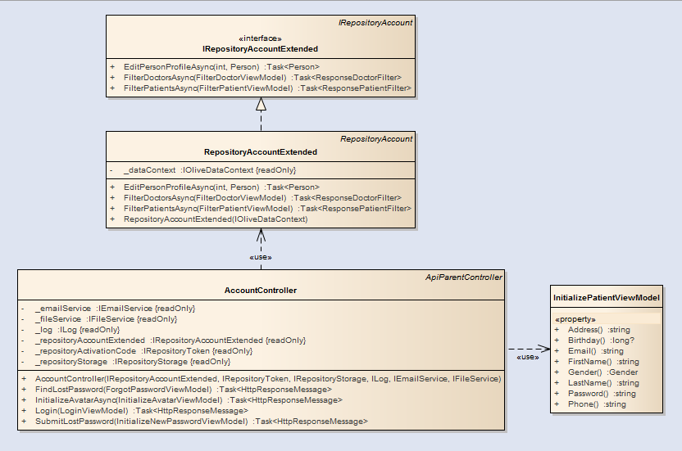

1. Class definition

InitializePatientViewModel class

Attribute

|  |  |  |  |
| --- | --- | --- | --- |
| No | Name | Type | Description |
| 1 | FirstName | string | First name of patient. |
| 2 | LastName | string | Last name of patient. |
| 3 | Birthday | double | Birthday of patient, the format is UTC. |
| 4 | Gender | Gender | Gender of patient, by default gender is: Gender.Male. |
| 5 | Email | string | Email which is used for logging into system. |
| 6 | Password | string | Password of account. |
| 7 | Phone | string | Phone number of patient. |
| 8 | Address | string | Address where patient lives. |

##### 6.2.1.3. Patient register account

1. Class diagram



1. Class definition

InitializePatientViewModel class

Attribute

|  |  |  |  |
| --- | --- | --- | --- |
| No | Name | Type | Description |
| 1 | FirstName | string | First name of patient. |
| 2 | LastName | string | Last name of patient. |
| 3 | Birthday | double | Birthday of patient, the format is UTC. |
| 4 | Gender | Gender | Gender of patient, by default gender is: Gender.Male. |
| 5 | Email | string | Email which is used for logging into system. |
| 6 | Password | string | Password of account. |
| 7 | Phone | string | Phone number of patient. |
| 8 | Address | string | Address where patient lives. |

##### 6.2.1.4. Forgot password

1. Sequence diagram

<TODO> Fill fill fill

##### 6.2.1.5. Request change password

1. Class diagram

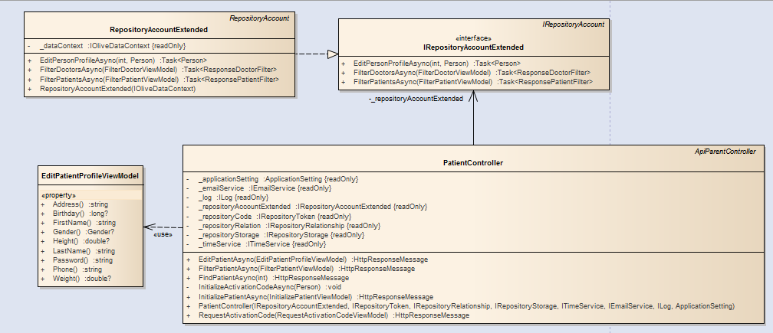

1. Sequence diagram

<TODO : FILL FILL FILL>

1. Class definition

PatientController class

Attribute

|  |  |  |  |
| --- | --- | --- | --- |
| No | Name | Type | Description |
| 1 | _repositoryAccountExtended | IRepositoryAccountExtended | Instance which is used for accessing function to IRepositoryAccountExtended. |
| 2 | _repositoryRelation | IRepositoryRelationship | Instance which is used for accessing function to IRepositoryRelationship. |
| 3 | _repositoryStorage | IRepositoryStorage | Instance which is used for accessing function to IRepositoryStorage. |
| 4 | _log | ILog | Instance which is used for accessing function to ILog. |
| 5 | _applicationSetting | ApplicationSetting | Instance which is used for accessing function to ApplicationSetting. |
| 6 | _timeService | ITimeService | Instance which is used for accessing function to ITimeService. |
| 7 | _repositoryCode | IRepositoryToken | Instance which is used for accessing function to IRepositoryToken. |
| 8 | _emailService | IEmailService | Instance which is used for accessing function to IEmailService. |

Method: FindPatientAsync()

|  |  |  |  |  |
| --- | --- | --- | --- | --- |
| Purpose | The function takes parameters requested from client and accessing database to find patient by using id. | | | |
| Return | **Type** | | | **Description** |
| HttpResponseMessage | | | Information which will be responded to client. |
| Parameter | **No** | **Name** | **Type** | **Description** |
| 1 | id | int | Id of patient. |

Method: InitializePatientAsync()

|  |  |  |  |  |
| --- | --- | --- | --- | --- |
| Purpose | The function takes parameters requested from client and initialize a patient object with the given information. | | | |
| Return | **Type** | | | **Description** |
| HttpResponseMessage | | | Information which will be responded to client. |
| Parameter | **No** | **Name** | **Type** | **Description** |
| 1 | info | InitializePatientViewModel | Information which contains patient’s information. |

Method: EditPatientAsync()

|  |  |  |  |  |
| --- | --- | --- | --- | --- |
| Purpose | The function takes parameters requested from client and edit patient profile. | | | |
| Return | **Type** | | | **Description** |
| HttpResponseMessage | | | Information which will be responded to client. |
| Parameter | **No** | **Name** | **Type** | **Description** |
| 1 | editor | EditPatientProfileViewModel | Information which contains patient’s information. |

Method: FilterPatientAsync()

|  |  |  |  |  |
| --- | --- | --- | --- | --- |
| Purpose | The function takes parameters requested from client and filter patients list. | | | |
| Return | **Type** | | | **Description** |
| HttpResponseMessage | | | Information which will be responded to client. |
| Parameter | **No** | **Name** | **Type** | **Description** |
| 1 | filter | FilterPatientViewModel | Model contains information which is used for filtering patients. |

Method: RequestActivationCode()

|  |  |  |  |  |
| --- | --- | --- | --- | --- |
| Purpose | This function takes information from client to initialize activation code for patient. | | | |
| Return | **Type** | | | **Description** |
| HttpResponseMessage | | | Information which will be responded to client. |
| Parameter | **No** | **Name** | **Type** | **Description** |
| 1 | initializer | RequestActivationCodeViewModel | Model contains information which is used for initializing patient activation token. |

EditPatientViewModel class

Attribute

|  |  |  |  |
| --- | --- | --- | --- |
| No | Name | Type | Description |
| 1 | FirstName | string | First name of patient. |
| 2 | LastName | string | Last name of patient. |
| 3 | Birthday | double | Birthday of patient, the format is UTC. |
| 4 | Gender | Gender | Gender of patient, by default gender is: Gender.Male. |
| 5 | Email | string | Email which is used for logging into system. |
| 6 | Password | string | Password of account. |
| 7 | Phone | string | Phone number of patient. |
| 8 | Address | string | Address where patient lives. |
| 9 | Weight | double? | Patient weight. |
| 10 | Height | double? | Patient height. |

##### 6.2.1.6. Find doctor

1. Class diagram

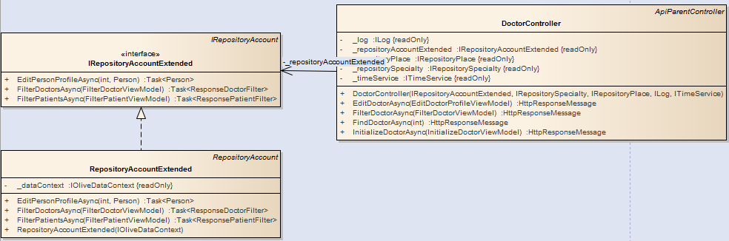

1. Class definition

DoctorController class

Attribute

|  |  |  |  |
| --- | --- | --- | --- |
| No | Name | Type | Description |
| 1 | _repositoryAccountExtended | IRepositoryAccountExtended | Instance which is used for accessing function to IRepositoryAccountExtended. |
| 2 | _repositorySpecialty | IRepositoryRelationship | Instance which is used for accessing function to IRepositorySpecialty. |
| 3 | _repositoryPlace | IRepositoryStorage | Instance which is used for accessing function to IRepositoryStorage. |
| 4 | _log | ILog | Instance which is used for accessing function to ILog. |
| 5 | _timeService | ITimeService | Instance which is used for accessing function to ITimeService. |

Method: FindDoctorAsync()

|  |  |  |  |  |
| --- | --- | --- | --- | --- |
| Purpose | The function takes parameters requested from client and accessing database to find doctor by using id. | | | |
| Return | **Type** | | | **Description** |
| HttpResponseMessage | | | Information which will be responded to client. |
| Parameter | **No** | **Name** | **Type** | **Description** |
| 1 | id | int | Id of doctor. |

Method: InitializeDoctorAsync()

|  |  |  |  |  |
| --- | --- | --- | --- | --- |
| Purpose | The function takes parameters requested from client, do validation and initialize a new patient into database. | | | |
| Return | **Type** | | | **Description** |
| HttpResponseMessage | | | Information which will be responded to client. |
| Parameter | **No** | **Name** | **Type** | **Description** |
| 1 | initializer | InitializeDoctorViewModel | Information of doctor. |

Method: EditDoctorAsync()

|  |  |  |  |  |
| --- | --- | --- | --- | --- |
| Purpose | The function takes parameters requested from client, do validation and modify a new patient into database. | | | |
| Return | **Type** | | | **Description** |
| HttpResponseMessage | | | Information which will be responded to client. |
| Parameter | **No** | **Name** | **Type** | **Description** |
| 1 | editor | EditDoctorProfileViewModel | Information of doctor. |

Method: FilterDoctorAsync()

|  |  |  |  |  |
| --- | --- | --- | --- | --- |
| Purpose | The function takes parameters requested from client, do validation and filter the list of doctors from database. | | | |
| Return | **Type** | | | **Description** |
| HttpResponseMessage | | | Information which will be responded to client. |
| Parameter | **No** | **Name** | **Type** | **Description** |
| 1 | filter | FilterDoctorViewModel | Conditions which are used for filtering. |

##### 6.2.1.7. Filter doctor rate

1. Class diagram

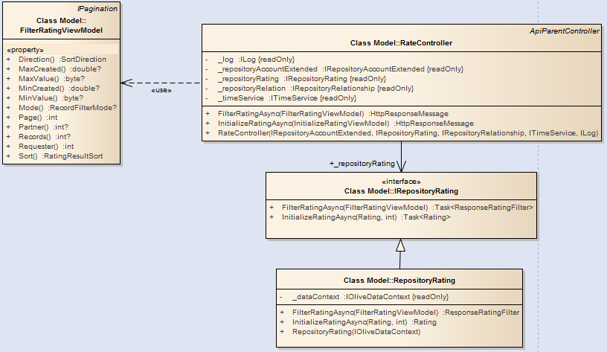

1. Class definition

DoctorController class

Attribute

|  |  |  |  |
| --- | --- | --- | --- |
| No | Name | Type | Description |
| 1 | _repositoryAccountExtended | IRepositoryAccountExtended | Instance which is used for accessing function to IRepositoryAccountExtended. |
| 2 | _repositoryRating | IRepositoryRating | Instance which is used for accessing function to IRepositoryRating. |
| 3 | _repositoryRelation | IRepositoryRelationship | Instance which is used for accessing function to IRepositoryRelationship. |
| 4 | _log | ILog | Instance which is used for accessing function to ILog. |
| 5 | _timeService | ITimeService | Instance which is used for accessing function to ITimeService. |

Method: InitializeRatingAsync()

|  |  |  |  |  |
| --- | --- | --- | --- | --- |
| Purpose | The function takes parameters requested from client and initializing a doctor rating into database. | | | |
| Return | **Type** | | | **Description** |
| HttpResponseMessage | | | Information which will be responded to client. |
| Parameter | **No** | **Name** | **Type** | **Description** |
| 1 | initializer | InitializeRatingViewModel | Information of rating. |

Method: FilterRatingAsync()

|  |  |  |  |  |
| --- | --- | --- | --- | --- |
| Purpose | The function takes parameters requested from client and filtering doctor ratings. | | | |
| Return | **Type** | | | **Description** |
| HttpResponseMessage | | | Information which will be responded to client. |
| Parameter | **No** | **Name** | **Type** | **Description** |
| 1 | filter | FilterRatingViewModel | Model contains information which are used for filtering ratings. |

RepositoryRating class

Attribute

|  |  |  |  |
| --- | --- | --- | --- |
| No | Name | Type | Description |
| 1 | _repositoryAccountExtended | IRepositoryAccountExtended | Instance which is used for accessing function to IRepositoryAccountExtended. |
| 2 | _repositoryRating | IRepositoryRating | Instance which is used for accessing function to IRepositoryRating. |
| 3 | _repositoryRelation | IRepositoryRelationship | Instance which is used for accessing function to IRepositoryRelationship. |
| 4 | _log | ILog | Instance which is used for accessing function to ILog. |
| 5 | _timeService | ITimeService | Instance which is used for accessing function to ITimeService. |

Method: InitializeRatingAsync()

|  |  |  |  |  |
| --- | --- | --- | --- | --- |
| Purpose | This function is for initializing rating to database. | | | |
| Return | **Type** | | | **Description** |
| Rating | | | Information of rating which has been created. |
| Parameter | **No** | **Name** | **Type** | **Description** |
| 1 | rated | int | Id of doctor who is rated. |
| 2 | rating | Rating | Rating information. |

Method: FilterRatingAsync()

|  |  |  |  |  |
| --- | --- | --- | --- | --- |
| Purpose | This function is for initializing rating to database. | | | |
| Return | **Type** | | | **Description** |
| Rating | | | Information of rating which has been created. |
| Parameter | **No** | **Name** | **Type** | **Description** |
| 1 | filter | FilterRatingViewModel | Conditions which are used for filtering rating. |

RepositoryRating class

Attribute

|  |  |  |  |
| --- | --- | --- | --- |
| No | Name | Type | Description |
| 1 | Requester | Person | Person who created filter request. |
| 2 | Partner | int | Id of partner. |
| 3 | Mode | RecordFilterMode? | Whether all ratings should be taken or not. |
| 4 | MinCreated | double? | Time after which rating is created. |
| 5 | MaxCreated | double? | Time before which rating had been created. |
| 6 | MinValue | double? | Minimum rating value. |
| 7 | MaxValue | double? | Maximum rating value. |
| 8 | Sort | RatingResultSort | Which property should be used for sorting purpose. |
| 9 | Direction | SortDirection | Whether property should be sorted ascendingly or decendingly. |
| 10 | Page | IRepositoryRelationship | Index of page result. |
| 11 | Records | IRepositoryRelationship | Number of records per page. |

##### 6.2.1.8. Initialize doctor rating

1. Class diagram

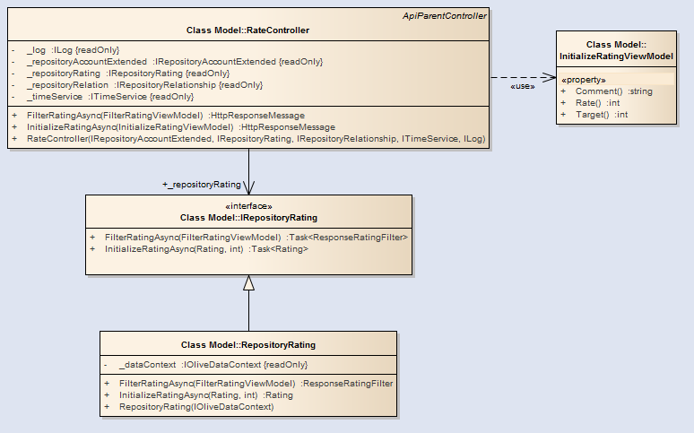

1. Class definition

InitializeRatingViewModel class

Attribute

|  |  |  |  |
| --- | --- | --- | --- |
| No | Name | Type | Description |
| 1 | Comment | string | Comment of rating. |
| 2 | Rate | int | Rating point. |
| 3 | Target | int | Doctor who is the target of rating. |

##### 6.2.1.9. Patient finds personal profile

1. Class diagram

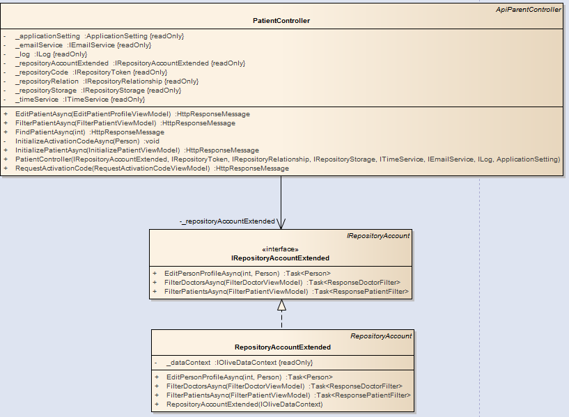

##### 6.2.1.10. Patient edit profile

1. Class diagram

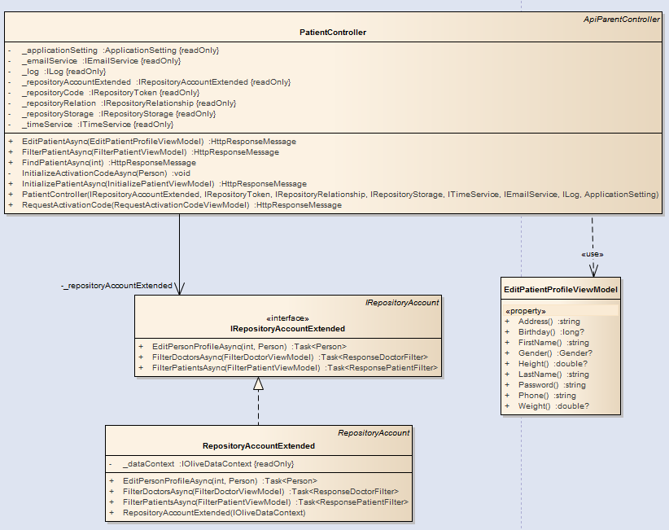

1. Class definition

EditPatientProfileViewModel class

Attribute

|  |  |  |  |
| --- | --- | --- | --- |
| No | Name | Type | Description |
| 1 | Address | string | Address of patient. |
| 2 | Birthday | double? | Birthday of patient. |
| 3 | FirstName | IRepositoryRelationship | First name of patient. |
| 4 | Gender | ILog | Gender of patient. |
| 5 | Height | ITimeService | Height of patient. |
| 6 | LastName | ITimeService | Last name of patient. |
| 7 | Password | ITimeService | Password of patient account. |
| 8 | Phone | ITimeService | Phone which patient uses. |
| 9 | Weight | ITimeService | Weight of patient. |

##### 6.2.1.11. Filter daily record

* Dialy records can belong to: Allergy, heartbeat, addiction, blood pressure, blood sugar.
* The data flow is : View -> <name>Controller -> IRepository<name> -> Repository<Name>.
* Name is one of the following: Heartbeat, Allergy, Addiction, BloodPressure, BloodSugar.
* They all have same diagrams and sequence diagrams.

1. Class diagram

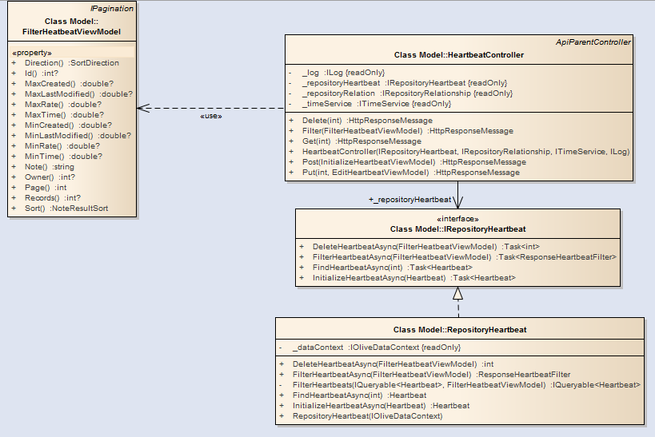

Class diagram of Heartbeat view.

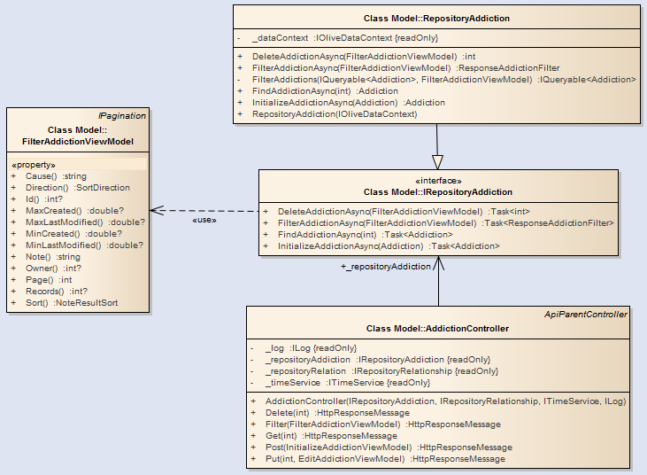

Class diagram of Addiction view.

1. Class definition

<name>Controller class

Attribute

|  |  |  |  |
| --- | --- | --- | --- |
| No | Name | Type | Description |
| 1 | _repository<name> | IRepository<name> | Instance which is used for accessing function to IRepository<name>. |
| 2 | _repositoryRelation | IRepositoryRelationship | Instance which is used for accessing function to IRepositoryRelationship. |
| 3 | _log | ILog | Instance which is used for accessing function to ILog. |
| 4 | _timeService | ITimeService | Instance which is used for accessing function to ITimeService. |

Method: Get()

|  |  |  |  |  |
| --- | --- | --- | --- | --- |
| Purpose | This function is for searching <name> note from database. | | | |
| Return | **Type** | | | **Description** |
| HttpResponseMessage | | | Data which will be sent to client. |
| Parameter | **No** | **Name** | **Type** | **Description** |
| 1 | id | int | Id of **<name>** note. |

Method: Post()

|  |  |  |  |  |
| --- | --- | --- | --- | --- |
| Purpose | This function is for initializing <name> note to database. | | | |
| Return | **Type** | | | **Description** |
| HttpResponseMessage | | | Data which will be sent to client. |
| Parameter | **No** | **Name** | **Type** | **Description** |
| 1 | info | Initialize**<name>**ViewModel | Information of **<name>** note which will be added into database. |

Method: Put()

|  |  |  |  |  |
| --- | --- | --- | --- | --- |
| Purpose | This function is for searching for a <name> note and updating its information. | | | |
| Return | **Type** | | | **Description** |
| HttpResponseMessage | | | Data which will be sent to client. |
| Parameter | **No** | **Name** | **Type** | **Description** |
| 1 | id | int | Id of **<name>** note whose information will be updated. |
| 2 | modifier | Initialize**<name>**ViewModel | Information of **<name>** note which will be updated into database. |

Method: Delete()

|  |  |  |  |  |
| --- | --- | --- | --- | --- |
| Purpose | This function is for searching for a <name> note and deleting its information. | | | |
| Return | **Type** | | | **Description** |
| HttpResponseMessage | | | Data which will be sent to client. |
| Parameter | **No** | **Name** | **Type** | **Description** |
| 1 | id | int | Id of **<name>** note whose information will be deleted. |

Method: Filter()

|  |  |  |  |  |
| --- | --- | --- | --- | --- |
| Purpose | This function is for filtering <name> notes by using specific conditions. | | | |
| Return | **Type** | | | **Description** |
| HttpResponseMessage | | | Data which will be sent to client. |
| Parameter | **No** | **Name** | **Type** | **Description** |
| 1 | filter | Filter**<name>**ViewModel | Conditions which are used for filtering **<name>** notes. |

Repository<name> class

Attribute

|  |  |  |  |
| --- | --- | --- | --- |
| No | Name | Type | Description |
| 1 | _dataContext | IOliveDataContext | Instance which is used for accessing function to IOliveDataContext. |

Method: Initialize<name>Async()

|  |  |  |  |  |
| --- | --- | --- | --- | --- |
| Purpose | This function is for searching <name> note from database. | | | |
| Return | **Type** | | | **Description** |
| <name> | | | Information of <name> note which has been initialized. |
| Parameter | **No** | **Name** | **Type** | **Description** |
| 1 | info | <name> | <name> note information. |

Method: Find<name>Async ()

|  |  |  |  |  |
| --- | --- | --- | --- | --- |
| Purpose | This function is for searching heartbeat note from database. | | | |
| Return | **Type** | | | **Description** |
| <name> | | | Information of <name> which is found in database. |
| Parameter | **No** | **Name** | **Type** | **Description** |
| 1 | id | int | Id of <name> note. |

Method: Delete<name>Async ()

|  |  |  |  |  |
| --- | --- | --- | --- | --- |
| Purpose | This function is for searching <name> note from database. | | | |
| Return | **Type** | | | **Description** |
| int | | | Number of records which have been deleted. |
| Parameter | **No** | **Name** | **Type** | **Description** |
| 1 | filter | Filter<name>ViewModel | Conditions which are used for finding <name> notes. |

Method: Filter<name>Async ()

|  |  |  |  |  |
| --- | --- | --- | --- | --- |
| Purpose | This function is for filtering <name> notes from database. | | | |
| Return | **Type** | | | **Description** |
| Response<name>Filter | | | Model contains list of filtered <name> notes and total number of filtered result. |
| Parameter | **No** | **Name** | **Type** | **Description** |
| 1 | filter | Filter<name>ViewModel | Conditions which are used for finding <name> notes. |

FilterHeatbeatViewModel class

Attribute

|  |  |  |  |
| --- | --- | --- | --- |
| No | Name | Type | Description |
| 1 | Id | int? | Id of heartbeat note. |
| 3 | Owner | int? | Id of note owner. |
| 4 | MinRate | double? | Minimum heart rate. |
| 5 | MaxRate | double? | Maximum heart rate. |
| 6 | Note | string | Note of heartbeat measurement. |
| 7 | MinTime | double? | Time which note is about. |
| 8 | MaxTime | double? | Time which note is about. |
| 9 | MinCreated | double? | Time after which note was submitted to server. |
| 10 | MaxCreated | double? | Time before which note had been submitted to server. |
| 11 | MinLastModified | double? | Time after which note was lastly modified. |
| 12 | MaxLastModified | double? | Time before whih note had been lastly modified. |
| 13 | Sort | NoteResultSort | Property which will be used for sorting. |
| 14 | Direction | SortDirection | Whether records are sorted ascendingly or decendingly. |
| 15 | Page | int | Index of result page. |
| 16 | Records | int | Number of record per page. |

FilterAddictionViewModel class

Attribute

|  |  |  |  |
| --- | --- | --- | --- |
| No | Name | Type | Description |
| 1 | Id | int? | Id of note. |
| 3 | Owner | int? | Id of note owner. |
| 4 | Cause | string | Which cause patient be allergic with. |
| 5 | Note | string | Note information. |
| 6 | MinCreated | double? | Time after which note was submitted to server. |
| 7 | MaxCreated | double? | Time before which note had been submitted to server. |
| 8 | MinLastModified | double? | Time after which note was lastly modified. |
| 9 | MaxLastModified | double? | Time before whih note had been lastly modified. |
| 10 | Sort | NoteResultSort | Property which will be used for sorting. |
| 11 | Direction | SortDirection | Whether records are sorted ascendingly or decendingly. |
| 12 | Page | int | Index of result page. |
| 13 | Records | int | Number of record per page. |

FilterAllergyViewModel class

Attribute

|  |  |  |  |
| --- | --- | --- | --- |
| No | Name | Type | Description |
| 1 | Id | int? | Id of note. |
| 3 | Owner | int? | Id of note owner. |
| 4 | Name | string | Allergy name. |
| 5 | Cause | string | Which cause patient be addictive with. |
| 6 | Note | string | Note information. |
| 7 | MinCreated | double? | Time after which note was submitted to server. |
| 8 | MaxCreated | double? | Time before which note had been submitted to server. |
| 9 | MinLastModified | double? | Time after which note was lastly modified. |
| 10 | MaxLastModified | double? | Time before whih note had been lastly modified. |
| 11 | Sort | NoteResultSort | Property which will be used for sorting. |
| 12 | Direction | SortDirection | Whether records are sorted ascendingly or decendingly. |
| 13 | Page | int | Index of result page. |
| 14 | Records | int | Number of record per page. |

FilterBloodPressureViewModel class

Attribute

|  |  |  |  |
| --- | --- | --- | --- |
| No | Name | Type | Description |
| 1 | Id | int? | Id of note. |
| 3 | Owner | int? | Id of note owner. |
| 4 | MinDiastolic | string | Value which diastolic must be greater than. |
| 5 | MaxDiastolic | string | Value which diastolic must be lower than. |
| 6 | MinSystolic | string | Value which systolic must be greater than. |
| 7 | MaxSystolic | string | Value which systolic must be greater than |
| 8 | Note | string | Note information. |
| 9 | MinCreated | double? | Time after which note was submitted to server. |
| 10 | MaxCreated | double? | Time before which note had been submitted to server. |
| 11 | MinLastModified | double? | Time after which note was lastly modified. |
| 12 | MaxLastModified | double? | Time before whih note had been lastly modified. |
| 13 | Sort | NoteResultSort | Property which will be used for sorting. |
| 14 | Direction | SortDirection | Whether records are sorted ascendingly or decendingly. |
| 15 | Page | int | Index of result page. |
| 16 | Records | int | Number of record per page. |

FilterBloodSugarViewModel class

Attribute

|  |  |  |  |
| --- | --- | --- | --- |
| No | Name | Type | Description |
| 1 | Id | int? | Id of note. |
| 2 | Owner | int? | Id of note owner. |
| 3 | Note | string | Note information. |
| 4 | MinValue | double? | Minimum value of note. |
| 5 | MaxValue | double? | Maximum value of note. |
| 6 | MinCreated | double? | Time after which note was submitted to server. |
| 7 | MaxCreated | double? | Time before which note had been submitted to server. |
| 8 | MinLastModified | double? | Time after which note was lastly modified. |
| 9 | MaxLastModified | double? | Time before whih note had been lastly modified. |
| 10 | Sort | NoteResultSort | Property which will be used for sorting. |
| 11 | Direction | SortDirection | Whether records are sorted ascendingly or decendingly. |
| 12 | Page | int | Index of result page. |
| 13 | Records | int | Number of record per page. |

##### 6.2.1.12. Edit daily record

1. Class diagram

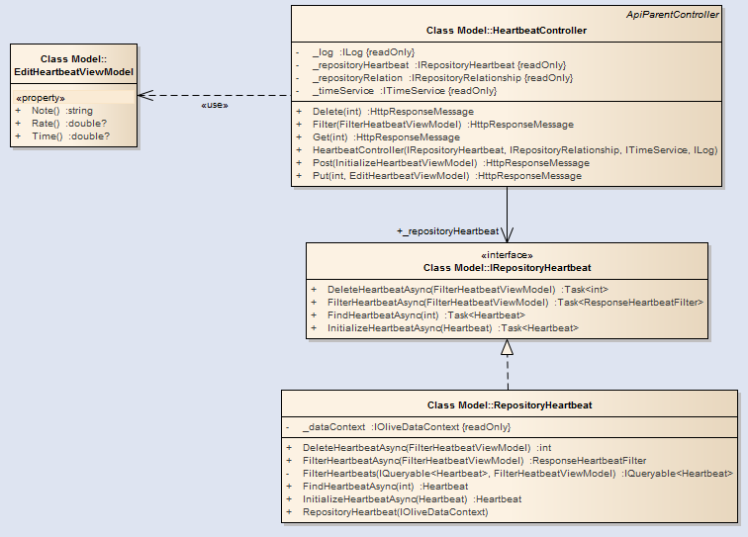

1. Class definition

EditHeartbeatViewModel class

Attribute

|  |  |  |  |
| --- | --- | --- | --- |
| No | Name | Type | Description |
| 1 | Note | string | Note of heartbeat measurement. |
| 2 | Rate | double? | Rate of note. |
| 3 | Time | double? | Time which note is about. |

EditAddictionViewModel class

Attribute

|  |  |  |  |
| --- | --- | --- | --- |
| No | Name | Type | Description |
| 1 | Cause | string | Cause of addiction. |
| 2 | Note | double? | Note of addiction. |

EditAllergyViewModel class

Attribute

|  |  |  |  |
| --- | --- | --- | --- |
| No | Name | Type | Description |
| 1 | Name | string | Name of allergy. |
| 2 | Cause | double? | Cause of allergy. |
| 3 | Note | double? | Note of allergy. |

EditBloodPressureViewModel class

Attribute

|  |  |  |  |
| --- | --- | --- | --- |
| No | Name | Type | Description |
| 1 | Diastolic | string | Blood minimum pressure. |
| 2 | Systolic | double? | Blood maximum pressure. |
| 3 | Time | double? | Time of blood pressure is measurement was done. |
| 4 | Note | string | Note of blood pressure measurement. |

EditBloodSugarViewModel class

|  |  |  |  |
| --- | --- | --- | --- |
| No | Name | Type | Description |
| 1 | Value | string | Blood sugar level. |
| 2 | Time | double? | Time when the measurement was done. |
| 3 | Note | double? | Note of measurement. |

Attribute

|  |  |  |  |
| --- | --- | --- | --- |
| No | Name | Type | Description |
| 1 | Diastolic | string | Blood minimum pressure. |
| 2 | Systolic | double? | Blood maximum pressure. |
| 3 | Time | double? | Time of blood pressure is measurement was done. |
| 3 | Note | string | Note of blood pressure measurement. |

##### 6.2.1.13. Delete daily record

1. Class diagram

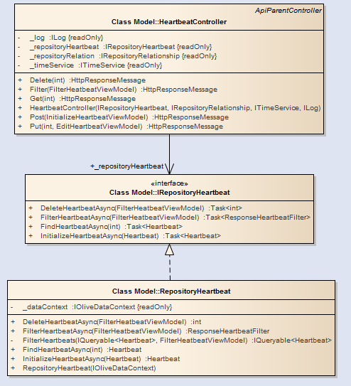

##### 6.2.1.14. Initialize daily record

1. Class diagram

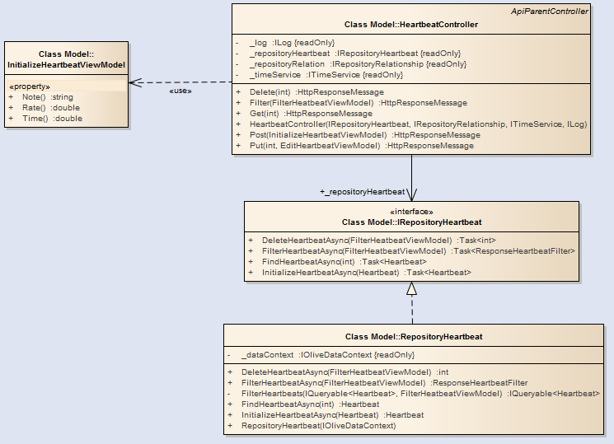

1. Class definition

InitializeHeartbeatViewModel class

Attribute

|  |  |  |  |
| --- | --- | --- | --- |
| No | Name | Type | Description |
| 1 | Note | string | Note of heartbeat measurement. |
| 2 | Rate | double | Rate of note. |
| 3 | Time | double | Time which note is about. |

InitializeHeartbeatViewModel class

Attribute

|  |  |  |  |
| --- | --- | --- | --- |
| No | Name | Type | Description |
| 1 | Note | string | Note of heartbeat measurement. |
| 2 | Rate | double | Rate of note. |
| 3 | Time | double | Time which note is about. |

InitializeAddictionViewModel class

Attribute

|  |  |  |  |
| --- | --- | --- | --- |
| No | Name | Type | Description |
| 1 | Cause | string | Note of heartbeat measurement. |
| 2 | Note | double | Rate of note. |

InitializeAllergyViewModel class

Attribute

|  |  |  |  |
| --- | --- | --- | --- |
| No | Name | Type | Description |
| 1 | Name | string | Name of allergy. |
| 2 | Cause | string | Cause of allergy. |
| 3 | Note | string | Note of allergy. |

InitializeBloodPressureViewModel class

Attribute

|  |  |  |  |
| --- | --- | --- | --- |
| No | Name | Type | Description |
| 1 | Diastolic | int | Blood minimum pressure. |
| 2 | Systolic | int | Blood maximum pressure. |
| 3 | Time | double | Time when the measurement is done. |
| 4 | Note | string | Note of measurement. |

InitializeBloodPressureViewModel class

Attribute

|  |  |  |  |
| --- | --- | --- | --- |
| No | Name | Type | Description |
| 1 | Value | int | Blood pressure value. |
| 2 | Time | int | Time when measurement is done. |
| 3 | Note | double | Note of measurement. |

##### 6.2.1.15. View Prescription

* Prescription contains : Prescription and Prescription image.
* They all following the naming convention: <name>Controller, <name>ViewModel, Repository<name>, IRepository<name>

1. Class diagram

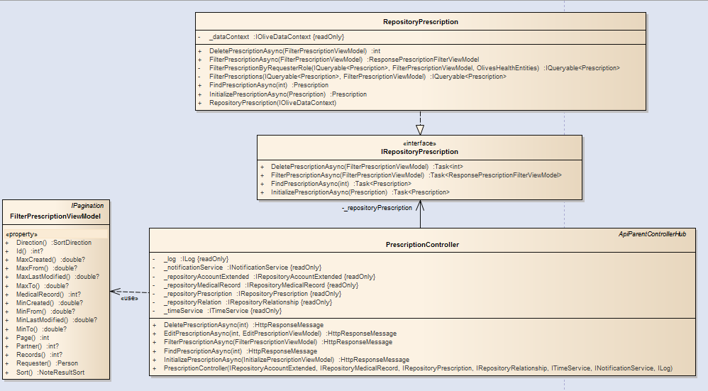

Class diagram of Prescription view.

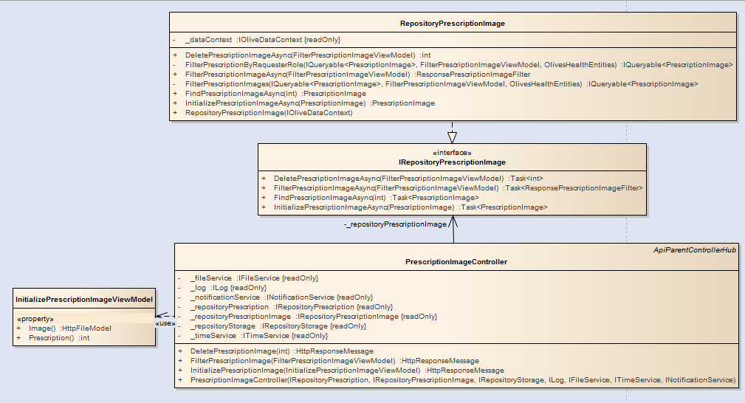

Class diagram of Prescription image view.

1. Class definition

<name>Controller class

Method: Filter<name>Async ()

|  |  |  |  |  |
| --- | --- | --- | --- | --- |
| Purpose | This function is for filtering <name> notes from database. | | | |
| Return | **Type** | | | **Description** |
| HttpResponseMessage | | | Model contains information which will be thrown to client. |
| Parameter | **No** | **Name** | **Type** | **Description** |
| 1 | filter | Filter**<name>**ViewModel | Conditions which are used for finding <name> notes. |

Method: Initialize<name>Async ()

|  |  |  |  |  |
| --- | --- | --- | --- | --- |
| Purpose | This function is for initializing <name> notes from database. | | | |
| Return | **Type** | | | **Description** |
| HttpResponseMessage | | | Model contains information which will be thrown to client. |
| Parameter | **No** | **Name** | **Type** | **Description** |
| 1 | initializer | Initialize**<name>**ViewModel | Model contains information which will be used for initializing. |

Method: Edit<name>Async ()

|  |  |  |  |  |
| --- | --- | --- | --- | --- |
| Purpose | This function is for modifying <name> notes from database. | | | |
| Return | **Type** | | | **Description** |
| HttpResponseMessage | | | Model contains information which will be thrown to client. |
| Parameter | **No** | **Name** | **Type** | **Description** |
| 1 | id | int | Id of record which will be modified. |
| 2 | info | Edit**<name>**ViewModel | Model contains information for updating record. |

Method: Delete<name>Async ()

|  |  |  |  |  |
| --- | --- | --- | --- | --- |
| Purpose | This function is for modifying <name> notes from database. | | | |
| Return | **Type** | | | **Description** |
| HttpResponseMessage | | | Model contains information which will be thrown to client. |
| Parameter | **No** | **Name** | **Type** | **Description** |
| 1 | id | int | Id of record which will be deleted. |

Repository<name> class

Method: Filter<name>Async ()

|  |  |  |  |  |
| --- | --- | --- | --- | --- |
| Purpose | This function is for filtering <name> notes from database. | | | |
| Return | **Type** | | | **Description** |
| Response<name>FilterViewModel | | | Model contains the list of filtered result and number which represents total filtered records. |
| Parameter | **No** | **Name** | **Type** | **Description** |
| 1 | filter | Filter**<name>**ViewModel | Conditions which are used for finding <name> notes. |

Method: Find<name>Async ()

|  |  |  |  |  |
| --- | --- | --- | --- | --- |
| Purpose | This function is for filtering <name> notes from database. | | | |
| Return | **Type** | | | **Description** |
| <name> | | | Instance which have been searched from database. |
| Parameter | **No** | **Name** | **Type** | **Description** |
| 1 | id | int | Index of result which will be used for searching in database. |

Method: Delete<name>Async ()

|  |  |  |  |  |
| --- | --- | --- | --- | --- |
| Purpose | This function is for deleting <name> notes from database by using specific conditions. | | | |
| Return | **Type** | | | **Description** |
| int | | | Number of deleted records. |
| Parameter | **No** | **Name** | **Type** | **Description** |
| 1 | filter | Filter<name>ViewModel | Model contains conditions which are used for filtering results which needed deleting. |

Method: Initialize<name>Async ()

|  |  |  |  |  |
| --- | --- | --- | --- | --- |
| Purpose | This function is for initializing/modifying <name> notes into/from database. | | | |
| Return | **Type** | | | **Description** |
| <name> | | | Instance which has been created/modified. |
| Parameter | **No** | **Name** | **Type** | **Description** |
| 1 | initializer | <name> | Model contain information which will be updated/initialized. |

InitializePrescriptionViewModel class

Attribute

|  |  |  |  |
| --- | --- | --- | --- |
| No | Name | Type | Description |
| 1 | MedicalRecord | int | Id of medical record. |
| 2 | Name | string | Name of prescription. |
| 3 | From | double | When the prescription should be available. |
| 4 | To | double | When the prescription should be expired. |
| 4 | Note | string | Note of prescription. |
| 5 | Medicines | Dictionary<string, MedicineInfoViewModel> | List of medicines which are included in prescription. |

InitializePrescriptionImageViewModel class

Attribute

|  |  |  |  |
| --- | --- | --- | --- |
| No | Name | Type | Description |
| 1 | Prescription | int | Prescription id. |
| 2 | Image | string | Byte stream of file submitted to server. |

##### 6.2.1.16. Edit Prescription

1. Class diagram

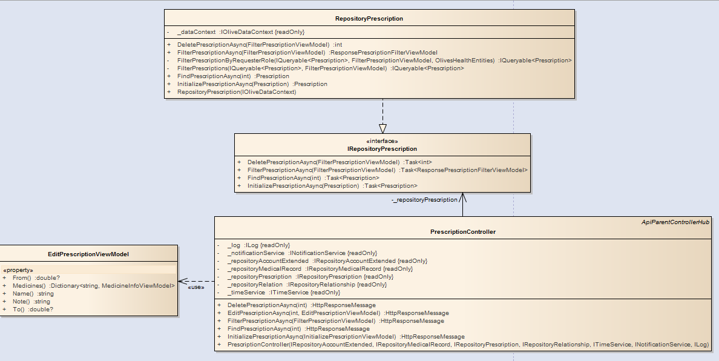

1. Class definition

EditPrescriptionViewModel class

Attribute

|  |  |  |  |
| --- | --- | --- | --- |
| No | Name | Type | Description |
| 1 | Name | int | Name of prescription. |
| 2 | From | string | When the prescription should be available. |
| 3 | To | double | When the prescription should be expired. |
| 4 | Dictionary<string, MedicineInfoViewModel> | double | Information of medicines inside a prescription. |
| 5 | Note | string | Note of prescription. |

##### 6.2.1.17. Delete Prescription

1. Class diagram

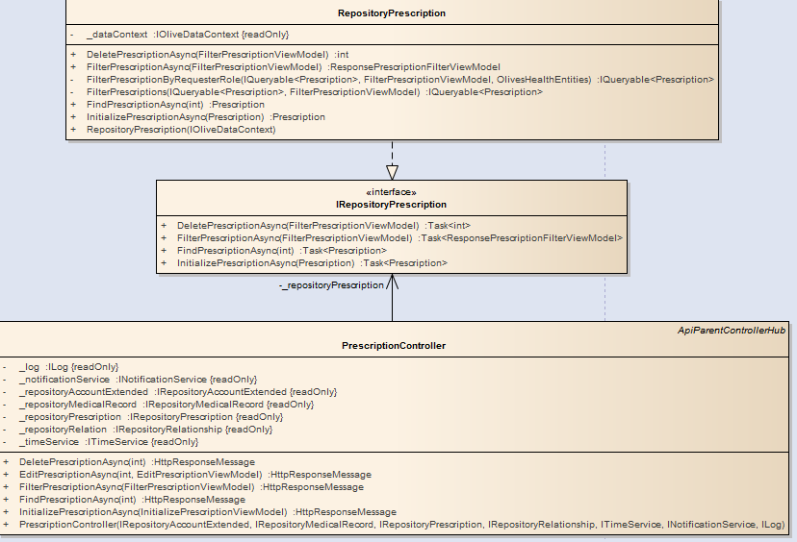

##### 6.2.1.18. View medical record

* Medical records can be: **Medical record**, **Medical images**, **Medical note**, **Experiment note**.
* The data flow is: View -> <name>Controller -> IRepository<name> -> Repository<Name>.
* Name is one of the following: **MedicalRecord**, **MedicalImage**, **MedicalNote**, **ExperimentNote**.
* They all have same diagrams and sequence diagrams.

1. Class diagram

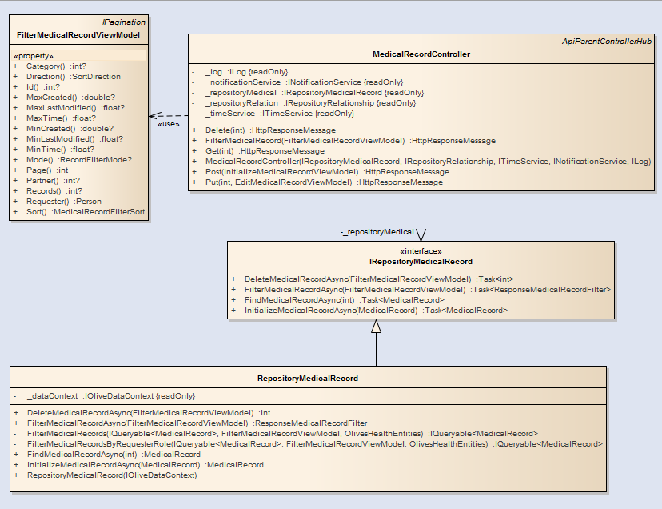

Diagram of Medical Record view.

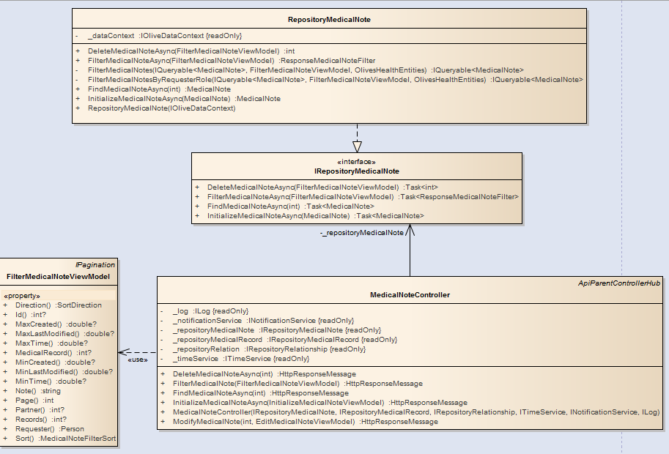

Diagram of Medical Note view.

1. Class definition

FilterMedicalNoteViewModel class

Attribute

|  |  |  |  |
| --- | --- | --- | --- |
| No | Name | Type | Description |
| 1 | Id | int | Id of medical note. |
| 2 | MedicalRecord | int | Medical record id which note belongs to. |
| 3 | Requester | Person | Requester who sent the filter request. |
| 4 | Partner | int? | Index of person who takes part in prescription. |
| 5 | Note | string | Note of medical note. |
| 6 | MinTime | double? | Time which note is about. |
| 7 | MaxTime | double? | Time which note is about. |
| 8 | MinCreated | double? | Time after which note was lastly created. |
| 9 | MaxCreated | double? | Time before which note had been created. |
| 10 | MinLastModified | double? | Time after which note was lastly modified. |
| 11 | MaxLastModified | double? | Time before which note had been modified. |
| 12 | Sort | MedicalNoteFilterSort | Which property should be sorted. |
| 13 | Direction | SortDirection | Whether records should be sorted ascendingly or decendingly. |
| 14 | Page | string | Index of result page. |
| 15 | Records | string | Results per page. |

FilterMedicalRecordViewModel class

Attribute

|  |  |  |  |
| --- | --- | --- | --- |
| No | Name | Type | Description |
| 1 | Id | int | Id of medical record. |
| 2 | Requester | Person | Requester who sent filter request. |
| 3 | Partner | int? | Who takes part in the medical record |
| 4 | Mode | RecordFilterMode? | Base on role of requester to filter medical records. |
| 5 | MinTime | double? | Time which the medical record is about. |
| 6 | MaxTime | double? | Time which the medical record is about. |
| 7 | Category | int | Index of category which medical record belongs to. |
| 8 | MinCreated | double? | Time after which medical record was created. |
| 9 | MaxCreated | double? | Time before which medical record had been created. |
| 10 | MinLastModified | double? | Time after which medical record was lastly modified. |
| 11 | MaxLastModified | double? | Time before which medical record had been modified. |
| 12 | Sort | MedicalRecordFilterSort? | Which property should be used for sorting. |
| 12 | Direction | SortDirection | Whether records should be sorted ascendingly or decendingly. |
| 12 | Page | int | Index of result page. |
| 12 | Records | int | Records number per page. |

FilterMedicalImageViewModel class

Attribute

|  |  |  |  |
| --- | --- | --- | --- |
| No | Name | Type | Description |
| 1 | Id | int | Id of medical image. |
| 2 | Requester | Person | Requester who sent filter request. |
| 3 | Partner | int? | Who takes part in the medical record |
| 4 | MedicalRecord | int | Index of medical record. |
| 4 | Mode | RecordFilterMode? | Base on role of requester to filter medical records. |
| 8 | MinCreated | double? | Time after which medical record was created. |
| 9 | MaxCreated | double? | Time before which medical record had been created. |
| 10 | Page | int | Index of result page. |
| 11 | Records | int | Records number per page. |

FilterExperimentNoteViewModel class

Attribute

|  |  |  |  |
| --- | --- | --- | --- |
| No | Name | Type | Description |
| 1 | Id | int? | Index of experiment note. |
| 4 | MedicalRecord | int | Index of medical record. |
| 2 | Requester | Person | Requester who sent filter request. |
| 4 | Name | string | Name of experiment note. |
| 8 | MinCreated | double? | Time after which medical record was created. |
| 9 | MaxCreated | double? | Time before which medical record had been created. |
| 8 | MinLastModified | double? | Time after which medical record was lastly modified. |
| 9 | MaxLastModified | double? | Time before which medical record had been modified. |
| 10 | Page | int | Index of result page. |
| 11 | Records | int | Records number per page. |

##### 6.2.1.19. Edit medical record

* The data flow is: View -> <name>Controller -> IRepository<name> -> Repository<Name>.
* Name is one of the following: **MedicalRecord**, **MedicalImage**, **MedicalNote**, **ExperimentNote**.
* They all have same diagrams and sequence diagrams.

1. Class diagram

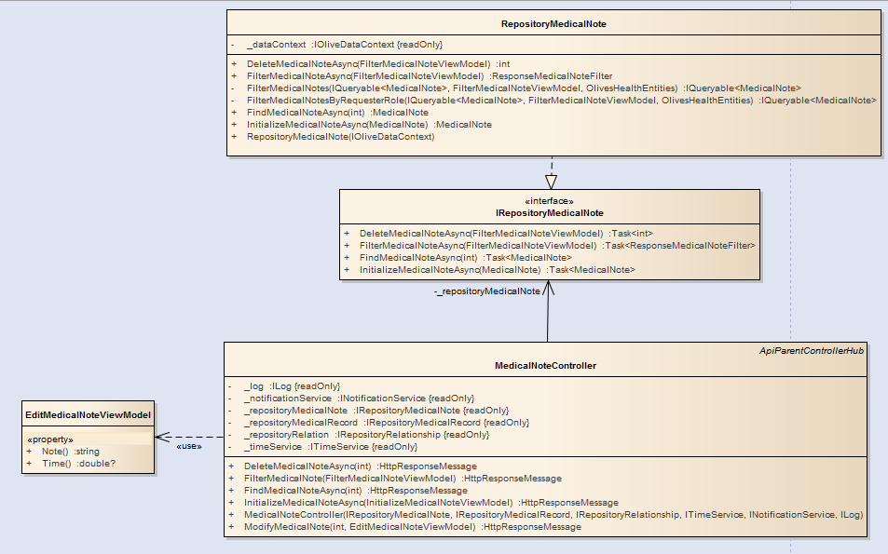

1. Class definition

EditExperimentNote class

Attribute

|  |  |  |  |
| --- | --- | --- | --- |
| No | Name | Type | Description |
| 1 | Name | int? | Index of experiment note. |
| 2 | Time | double? | Time which note is about. |
| 3 | Infos | Dictionary<string, double> | Information of experiments. |

EditMedicalNoteViewModel class

Attribute

|  |  |  |  |
| --- | --- | --- | --- |
| No | Name | Type | Description |
| 1 | Note | string | Note of medical. |
| 2 | Time | double? | Time which note is about. |

EditMedicalRecordViewModel class

Attribute

|  |  |  |  |
| --- | --- | --- | --- |
| No | Name | Type | Description |
| 1 | Category | string | Note of medical. |
| 2 | Name | string | Name of medical record. |
| 3 | Infos | Dictionary<string, string> | Information of medical state. |
| 4 | Time | double? | Time which note is about. |

##### 6.2.1.20. Add medical record

InitializeMedicalImageViewModel class

Attribute

|  |  |  |  |
| --- | --- | --- | --- |
| No | Name | Type | Description |
| 1 | MedicalRecord | int | Index of medical record which contains image. |
| 2 | File | HttpFileModel | Image file. |

InitializeMedicalNoteViewModel class

Attribute

|  |  |  |  |
| --- | --- | --- | --- |
| No | Name | Type | Description |
| 1 | MedicalRecord | int | Index of medical record which contains image. |
| 2 | Note | string | Note of medical. |
| 3 | Time | double | Time when note is about. |

InitializeMedicalRecordViewModel class

Attribute

|  |  |  |  |
| --- | --- | --- | --- |
| No | Name | Type | Description |
| 1 | Owner | int | Medical record owner. |
| 2 | Creator | string | Creator of medical record. |
| 3 | Name | string | Name of medical record. |
| 4 | Category | int | Category which medical record belongs to. |
| 5 | Infos | Dictionary<string, string> | Time when note is about. |
| 6 | Time | double | Time when note is about. |

##### 6.2.1.21. Delete medical record

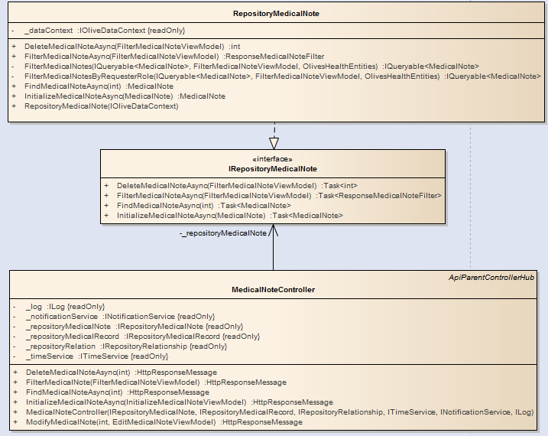

Diagram of Medical note delete.

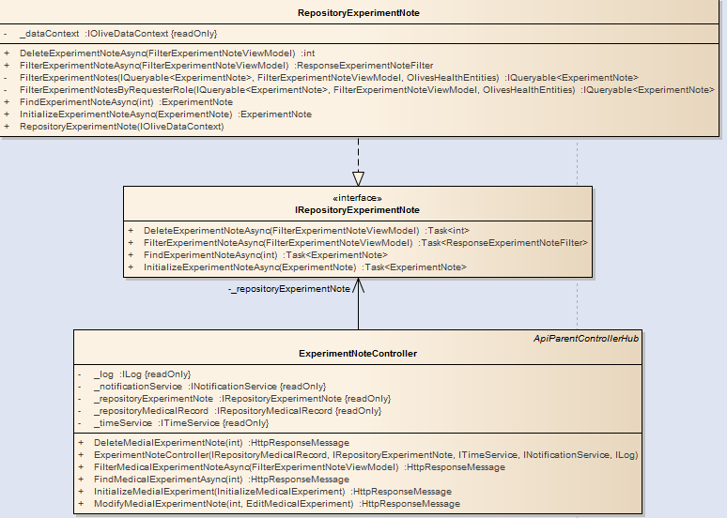

Diagram of Experiment note delete

##### 6.2.1.22. Create appointment

1. Class diagram

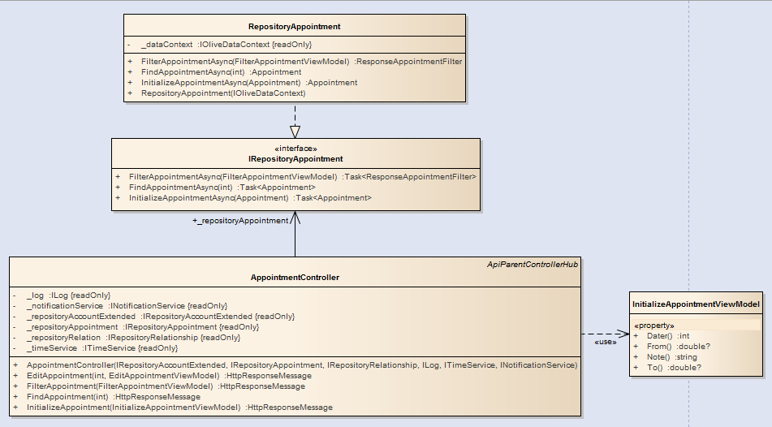

1. Class definition

AppointmentController class

Attribute

|  |  |  |  |
| --- | --- | --- | --- |
| No | Name | Type | Description |
| 1 | _repositoryAccountExtended | IRepositoryAccountExtended | Instance which is used for accessing function to IRepositoryAccountExtended. |
| 2 | _repositoryAppointment | IRepositoryAppointment | Instance which is used for accessing function to IRepositoryAppointment. |
| 3 | _notificationService | INotificationService | Instance which is used for accessing function to INotificationService. |
| 4 | _timeService | ITimeService | Instance which is used for accessing function to ITimeService. |
| 5 | _log | ILog | Instance which is used for accessing function to ILog. |

Method: FindAppointmentAsync()

|  |  |  |  |  |
| --- | --- | --- | --- | --- |
| Purpose | Find appointment by using id and throw result back to client-side. | | | |
| Return | **Type** | | | **Description** |
| HttpResponseMessage | | | Data which will be sent to client. |
| Parameter | **No** | **Name** | **Type** | **Description** |
| 1 | id | int | Id of appointment. |

Method: InitializeAppointmentAsync()

|  |  |  |  |  |
| --- | --- | --- | --- | --- |
| Purpose | Initialize an appointment into database throw result back to client-side. | | | |
| Return | **Type** | | | **Description** |
| HttpResponseMessage | | | Data which will be sent to client. |
| Parameter | **No** | **Name** | **Type** | **Description** |
| 1 | initializer | InitializeAppointmentViewModel | Information of appointment. |

Method: EditAppointmentAsync()

|  |  |  |  |  |
| --- | --- | --- | --- | --- |
| Purpose | Modify an appointment in database throw result back to client-side. | | | |
| Return | **Type** | | | **Description** |
| HttpResponseMessage | | | Data which will be sent to client. |
| Parameter | **No** | **Name** | **Type** | **Description** |
| 1 | id | int | Id of appointment which needs changing. |
| 2 | info | EditAppointmentViewModel | Information of appointment which will be used for being updated. |

Method: FilterAppointmentAsync()

|  |  |  |  |  |
| --- | --- | --- | --- | --- |
| Purpose | Filter appointments from database throw result back to client-side. | | | |
| Return | **Type** | | | **Description** |
| HttpResponseMessage | | | Data which will be sent to client. |
| Parameter | **No** | **Name** | **Type** | **Description** |
| 1 | filter | FilterAppointmentViewModel | Conditions which are used for filtering appointments from database. |

AppointmentController class

Attribute

|  |  |  |  |
| --- | --- | --- | --- |
| No | Name | Type | Description |
| 1 | Dater | int | Person who is the target of appointment. |
| 2 | From | double? | Time when the appointment should be started. |
| 3 | To | double? | Time when the appointment should be ended. |
| 4 | Note | string | Note of appointment. |

##### 6.2.1.23. View appointment

1. Class diagram

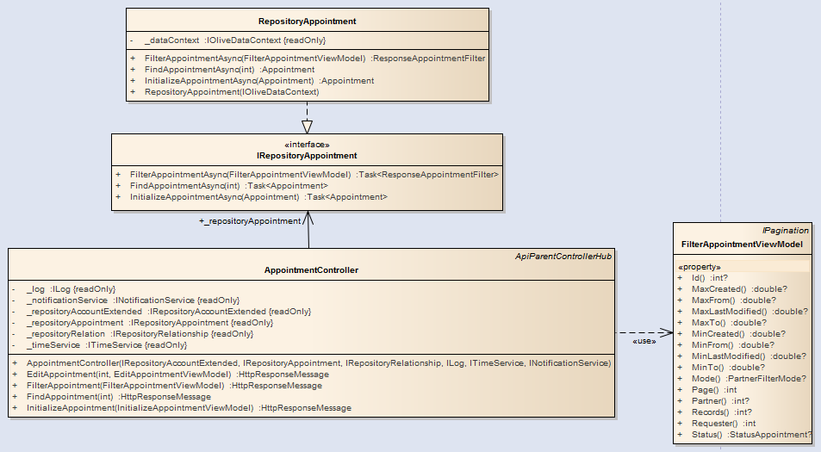

1. Class definition

AppointmentController class

Attribute

|  |  |  |  |
| --- | --- | --- | --- |
| No | Name | Type | Description |
| 1 | Mode | int | Person who is the target of appointment. |
| 2 | Partner | int? | Time when the appointment should be started. |
| 3 | Requester | Person | Time when the appointment should be ended. |
| 4 | Id | int | Id of appointment. |
| 5 | MinCreated | double? | Time after which appointment was created. |
| 6 | MaxCreated | double? | Time before which appointment had been created. |
| 7 | MinFrom | double? | Time after which appointment should be started. |
| 8 | MaxFrom | double? | Time after which appointment should be started. |
| 9 | MinTo | double? | Time after which appointment should be expired. |
| 10 | MaxTo | double? | Time before which appointment should be expired. |
| 11 | Status | StatusAppointment? | Status of appointment. |
| 12 | MinLastModified | double? | Time after which appointment was lastly modified. |
| 13 | MaxLastModified | double? | Time before which appointment had been modified. |
| 14 | Page | int | Index of result page. |
| 15 | Records | int? | Number of records per page. |

##### 6.2.1.24. Accept appointment

1. Class diagram

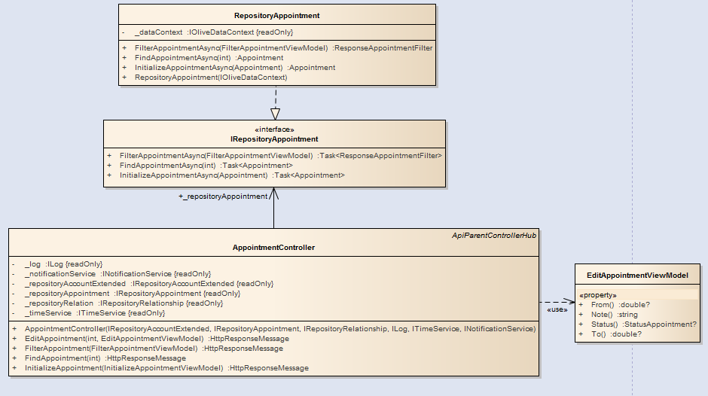

1. Class definition

EditAppointmentViewModel class

Attribute

|  |  |  |  |
| --- | --- | --- | --- |
| No | Name | Type | Description |
| 1 | From | double? | Person who is the target of appointment. |
| 2 | Note | string | Time when the appointment should be started. |
| 3 | Status | StatusAppointment? | Status of appointment. |
| 4 | To | double? | Time after which appointment will be expired. |

##### 6.2.1.25. Cancel appointment

1. Class diagram



##### 6.2.1.26. Connect/disconnect to/from doctor

1. Class diagram

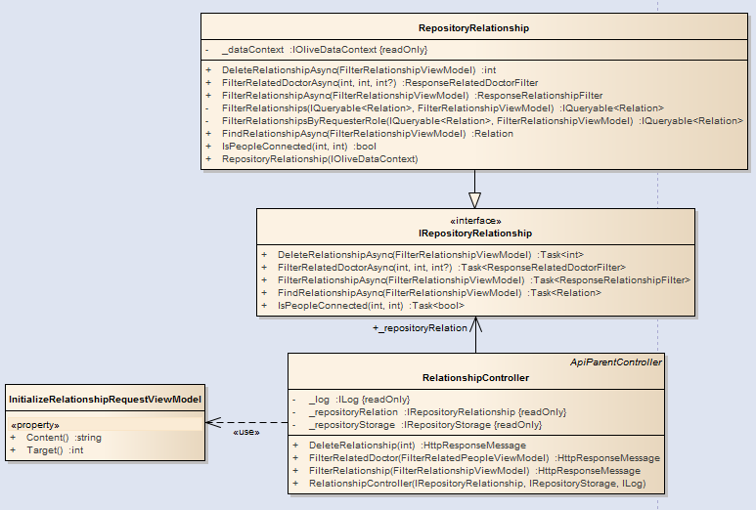

1. Class definition

RepositoryRelationship class

Attribute

|  |  |  |  |
| --- | --- | --- | --- |
| No | Name | Type | Description |
| 1 | _log | ILog | Instance which is used for accessing function to ILog. |
| 2 | _repositoryRelation | IRepositoryRelationship | Instance which is used for accessing function to IRepositoryRelationship. |
| 3 | _repositoryStorage | IRepositoryStorage | Instance which is used for accessing function to IRepositoryStorage. |

Method: DeleteRelationship()

|  |  |  |  |  |
| --- | --- | --- | --- | --- |
| Purpose | Delete relationship by using conditions. | | | |
| Return | **Type** | | | **Description** |
| int | | | Number of records which have been deleted. |
| Parameter | **No** | **Name** | **Type** | **Description** |
| 1 | id | int | Id of appointment. |

Method: FilterRalatedDoctorAsync()

|  |  |  |  |  |
| --- | --- | --- | --- | --- |
| Purpose | Filter doctor who has relationship with the requester by using conditions. | | | |
| Return | **Type** | | | **Description** |
| ResponseRelatedDoctorFilter | | | Model which contains list of filtered result and number represents the total condition matched result. |
| Parameter | **No** | **Name** | **Type** | **Description** |
| 1 | requester | int | Id of person who sent filter request. |
| 2 | page | int | Id of requester who sent filter request. |
| 3 | record | int | Id of requester who sent filter request. |

Method: IsPeopleConnected()

|  |  |  |  |  |
| --- | --- | --- | --- | --- |
| Purpose | Check whether 2 people are connected or not. | | | |
| Return | **Type** | | | **Description** |
| bool | | | True if people are connected and vice versa. |
| Parameter | **No** | **Name** | **Type** | **Description** |
| 1 | firstPerson | int | Id of first person. |
| 2 | secondPerson | int | Id of second person. |

##### 6.2.1.27. Chat

1. Class diagram

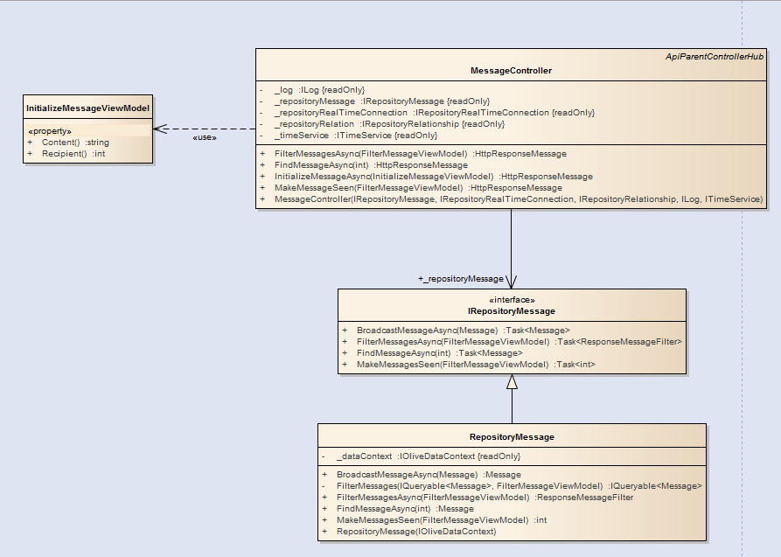

RepositoryRelationship class

Attribute

|  |  |  |  |
| --- | --- | --- | --- |
| No | Name | Type | Description |
| 1 | _repositoryRelation | IRepositoryRelationship | Instance which is used for accessing function to IRepositoryRelationship. |
| 2 | _repositoryRealTimeConnection | IRepositoryRealTimeConnection | Instance which is used for accessing function to IRepositoryRealTimeConnection. |
| 3 | _repositoryMessage | IRepositoryMessage | Instance which is used for accessing function to IRepositoryMessage. |
| 4 | _timeService | ITimeService | Instance which is used for accessing function to ITimeService. |
| 5 | _log | ILog | Instance which is used for accessing function to ILog. |

Method: FindMessageAsync()

|  |  |  |  |  |
| --- | --- | --- | --- | --- |
| Purpose | Find message by using. | | | |
| Return | **Type** | | | **Description** |
| HttpResponseMessage | | | Instance of result which will be thrown back to client. |
| Parameter | **No** | **Name** | **Type** | **Description** |
| 1 | id | int | Id of message. |

Method: InitializeMessageAsync()

|  |  |  |  |  |
| --- | --- | --- | --- | --- |
| Purpose | Initialize a message into database and broadcast it to recipient. | | | |
| Return | **Type** | | | **Description** |
| HttpResponseMessage | | | . |
| Parameter | **No** | **Name** | **Type** | **Description** |
| 1 | initializer | InitializeMessageViewModel | Instance of message. |

Method: InitializeMessageAsync()

|  |  |  |  |  |
| --- | --- | --- | --- | --- |
| Purpose | Initialize a message into database and broadcast it to recipient. | | | |
| Return | **Type** | | | **Description** |
| HttpResponseMessage | | | . |
| Parameter | **No** | **Name** | **Type** | **Description** |
| 1 | initializer | InitializeMessageViewModel | Instance of message. |

Method: MakeMessageSeen()

|  |  |  |  |  |
| --- | --- | --- | --- | --- |
| Purpose | Mark the message as having been seen. | | | |
| Return | **Type** | | | **Description** |
| HttpResponseMessage | | | Instance contains result which will be thrown back to client. |
| Parameter | **No** | **Name** | **Type** | **Description** |
| 1 | initializer | FilterMessageViewModel | Instance which contains condition for filtering messages. |

##### 6.2.1.28. View Diary

1. Class diagram

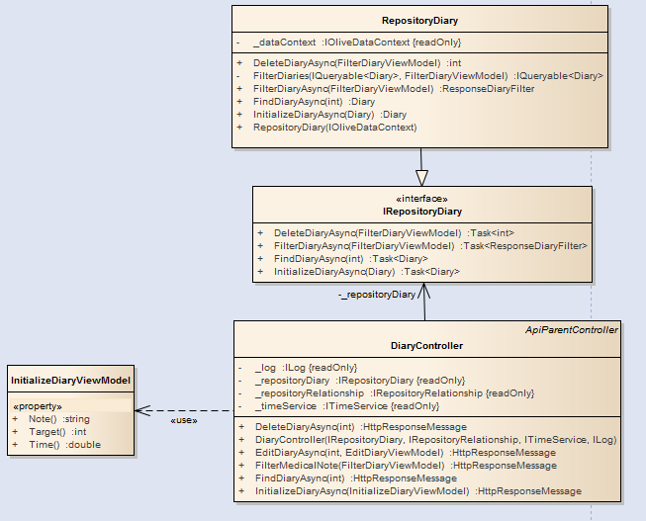

1. Class definition

RepositoryDiary class

Attribute

|  |  |  |  |
| --- | --- | --- | --- |
| No | Name | Type | Description |
| 1 | _repositoryRelation | IRepositoryRelationship | Instance which is used for accessing function to IRepositoryRelationship. |
| 2 | _repositoryRealTimeConnection | IRepositoryRealTimeConnection | Instance which is used for accessing function to IRepositoryRealTimeConnection. |
| 3 | _repositoryMessage | IRepositoryMessage | Instance which is used for accessing function to IRepositoryMessage. |
| 4 | _timeService | ITimeService | Instance which is used for accessing function to ITimeService. |

Method: DeleteDiaryAsync()

|  |  |  |  |  |
| --- | --- | --- | --- | --- |
| Purpose | Delete diary by using specific conditions asynchronously. | | | |
| Return | **Type** | | | **Description** |
| HttpResponseMessage | | | Instance contains response which will be thrown back to client-side. |
| Parameter | **No** | **Name** | **Type** | **Description** |
| 1 | filter | FilterDiaryViewModel | Instance which contains condition for filtering diaries. |

Method: FilterDiaryAsync()

|  |  |  |  |  |
| --- | --- | --- | --- | --- |
| Purpose | Filter diaries by using specific conditions. | | | |
| Return | **Type** | | | **Description** |
| HttpResponseMessage | | | Instance contains response which will be thrown back to client-side. |
| Parameter | **No** | **Name** | **Type** | **Description** |
| 1 | filter | FilterDiaryViewModel | Instance which contains condition for filtering diaries. |

Method: InitializeDiaryAsync()

|  |  |  |  |  |
| --- | --- | --- | --- | --- |
| Purpose | Filter diaries by using specific conditions. | | | |
| Return | **Type** | | | **Description** |
| HttpResponseMessage | | | Instance contains response which will be thrown back to client-side. |
| Parameter | **No** | **Name** | **Type** | **Description** |
| 1 | filter | InitializeDiaryViewModel | Model contains information of diary. |

##### 6.2.1.29. Edit Diary

1. Class diagram

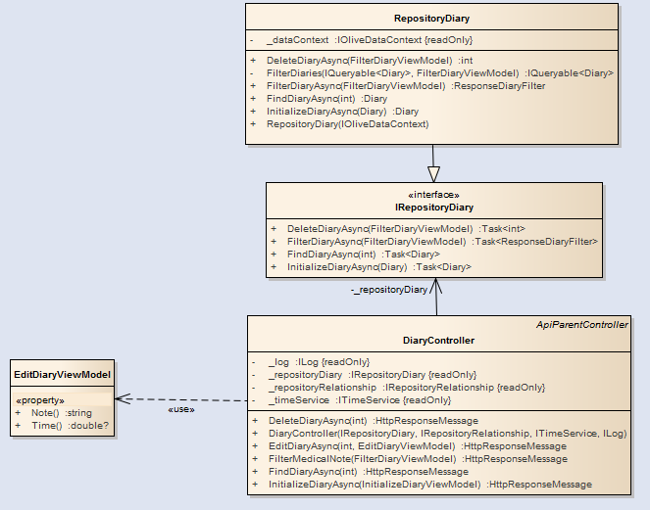

1. Class definition

EditDiaryViewModel class

Attribute

|  |  |  |  |
| --- | --- | --- | --- |
| No | Name | Type | Description |
| 1 | Time | double | Time of diary. |
| 2 | Note | Note | Note of diary. |

##### 6.2.1.30. Delete Diary

1. Class diagram

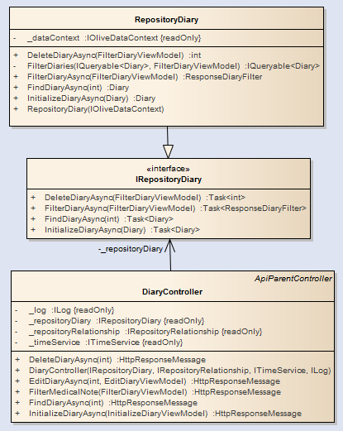

##### 6.2.1.30. Initialize a diary

1. Class diagram

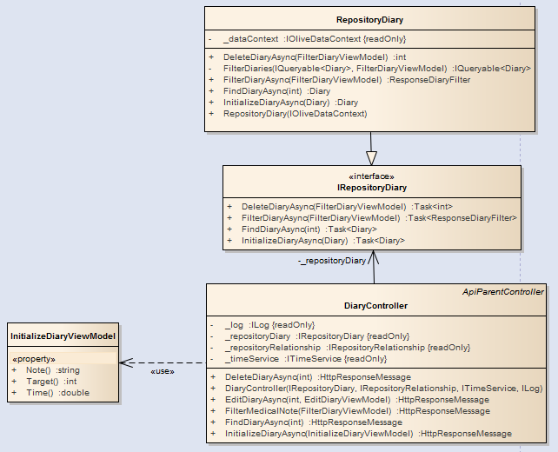

1. Class definition

InitializeDiaryViewModel class

Attribute

|  |  |  |  |
| --- | --- | --- | --- |
| No | Name | Type | Description |
| 1 | Target | int | Id of patient who diary is about. |
| 2 | Time | double | Time of diary. |
| 3 | Note | Note | Note of diary. |